CSS GENDER STUDIES
T6QA
The Question Answers
Topic 6 · Gender and Governance — every past question answered as a model
WHAT THIS DOCUMENT GIVES YOU
◆ All eight CSS questions on Topic 6 (2016–2025) and the short note on the suffragist movement, answered in full
◆ An answer map for every answer — each branch a numbered heading
◆ The command words and limbs of every question decoded
◆ Model answers of 1,000–1,300 words (note 550–650) with Pakistan's quota history and the 2024 election data inside every heading
◆ Why each answer scores — what the examiner rewards
Federal Public Service Commission · CSS Competitive Examination · Optional paper, 100 marks
Written for CE-2027 onwards · Record: CE-2016 to CE-2026 · Facts current to September 2026

Contents
HOW TO BUILD THE CONTENTS
The contents list below fills itself in. When Word asks "This document contains fields that may refer to other files. Update the fields?", click Yes.
If it does not ask: right-click the grey contents area → Update Field → Update entire table → OK. On a Mac, Control-click the same area. Or press Ctrl + A, then F9 (Windows), to update every field at once. Repeat after any edit, before you export to PDF.

Right-click here and choose Update Field to build the contents.

How to Use These Answers

What is in this document
Table 1 · The questions answered for Topic 6, in the order they were set.
No. | Question | Year · Q | Family
1 | What are the pros and cons of gender quota in politics? Give your views on the impact of gender quota in politics in Pakistan. | CSS 2016 · Q4 | Political quotas for women
2 | 'Women's active political participation could stabilize democracy and boost economic development.' Comment on this statement within the cont… | CSS 2017 · Q4 | Women's political participation
3 | Believing in the statement that 'women cover half the sky', do you think we need an equal number of women in all spheres of the public domai… | CSS 2018 · Q7 | Women's political participation
4 | Suffragist movement | CSS 2019 · Q8(a) | The suffragist movement
5 | Women need to be in leadership positions to pull more women into leadership roles. Is this suggestion that women need to 'pull each other up… | CSS 2020 · Q5 | Women in leadership
6 | Despite the entry of women legislators into politics on a 17 percent quota in national and provincial assemblies, there are still voices ask… | CSS 2021 · Q8 | Political quotas for women
7 | In your opinion, what are the main issues faced by women as representatives in Pakistan? | CSS 2022 · Q5 | Women as representatives / politicians
8 | Is political participation a human right? If so, what obstacles are faced by women politicians in Pakistan in pursuing a career in politics?… | CSS 2024 · Q7 | Women's political participation; Political quotas for women
9 | Elaborate the historical context and evolution of women's quota in Pakistan concerning key legislation and policies that have shaped the quo… | CSS 2025 · Q5 | Political quotas for women

How every answer is built
1. The question, exactly as set, with its year and number.
2. The answer map — a mind map whose centre states what the question asks, part by part. Every branch is one numbered heading of the answer, and every point on it is a short phrase that makes complete sense on its own — so the map alone tells the examiner the whole argument. Draw a quick version in the margin of your answer book before you write.
3. Decoding the question — the command words and what each part demands.
4. The model answer — 1,000 to 1,300 words (550 to 650 for a short note), the length a strong candidate can write in about thirty minutes. It is built in two levels: main headings 1, 2, 3… taken from the question's own words, and sub-headings i), ii), iii)… under them. The introduction always has a simple definition and the argument. Each sub-heading answers one point in a short paragraph with the key words in bold. Every answer has at least one figure besides the answer map (a comparison, flow, cycle, pyramid, grid, timeline or mapping), a Pakistan angle and a balanced conclusion.
5. Why this answer scores — what the examiner rewards in it.
EXAMINER'S EYE · TOPIC 6 IS A TOPIC OF JUDGEMENTS
Almost every question here asks you to judge: pros and cons (2016), "comment" (2017), "do you think" (2018), "useful or preferential" (2020), "is it showing results?" (2021), "in your opinion" (2022), "is it a human right?" (2024). Notice how the same core material is re-cut each time — Pitkin (descriptive vs substantive representation), Dahlerup (fast track, critical mass), the quota history (1956, 1962, 1973, 1985, the lapse, 2002, 2017), the caucus laws of 2010–2016, and the 2024 numbers (60 reserved seats, 306 women candidates, 11 winners, 9.94 million fewer women voters). Every answer ends with a clear view and reforms: direct election, a stronger candidate quota in winnable seats, and party democracy.

Answer 1 · The Pros and Cons of Gender Quotas and Their Impact in Pakistan (CSS 2016)
AT A GLANCE · CSS 2016 · Q4 · 20 MARKS
What are the pros and cons of gender quota in politics? Give your views on the impact of gender quota in politics in Pakistan.

The answer map
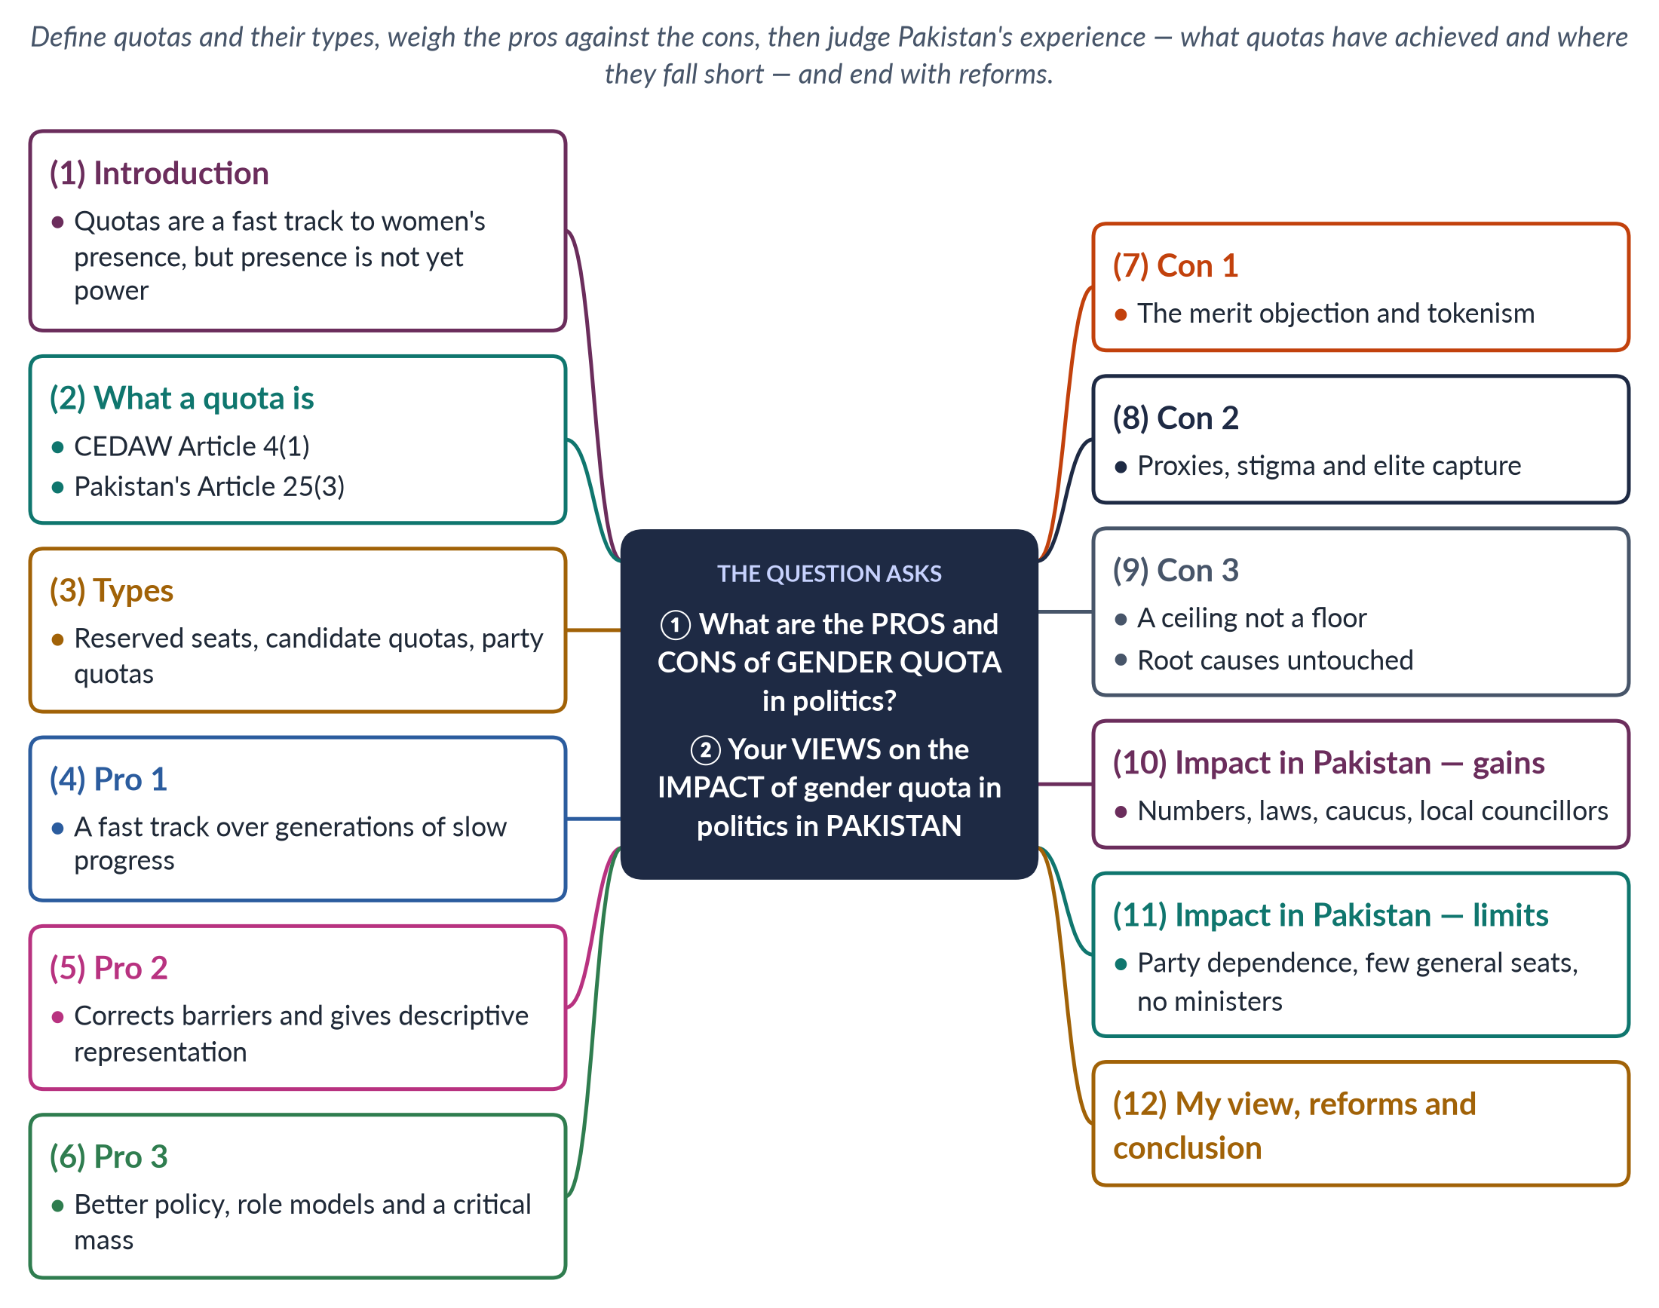
Figure 1 · The answer map: every branch is one numbered heading of the model answer below.

Decoding the question
Two parts. "Pros and cons" asks for a balanced treatment of arguments for and against quotas in general. "Give your views on the impact… in Pakistan" asks for a judgement based on Pakistani evidence — numbers, laws and limits. Use the theory of representation (descriptive vs substantive) to frame your view, and end with reforms.

The model answer

1. Introduction

i) Definition
A gender quota is a rule that requires a minimum number or share of women in a political body — a legislature, a candidate list or a party organ.

ii) The argument
Quotas are the fastest proven way to bring women into politics, and their benefits outweigh their costs. In Pakistan the quota has delivered presence — about one-fifth of the National Assembly — and real laws for women, but not yet power, because reserved-seat women depend on party leaders. Better design, not abolition, is the answer.

2. What a quota is
Quotas are temporary special measures. Article 4(1) of CEDAW (1979) declares that such measures "shall not be considered discrimination", and Pakistan's Article 25(3) allows special provision for women. Their aim is to correct a historical imbalance until equal participation becomes normal. More than 130 countries now use some form of political gender quota, and women's share of seats in national parliaments worldwide has risen to a little over a quarter — much of that rise driven by quotas.

3. Types of quota
1. Reserved seats guarantee a result: Pakistan's 60 National Assembly seats, Bangladesh's 50.
2. Legislated candidate quotas require parties to nominate women: Pakistan's 5% of general tickets (Elections Act 2017), France's parity law (2000).
3. Voluntary party quotas are parties' own rules, common in Scandinavia.

4. Pro 1: a fast track
Without quotas, women's representation rises very slowly. The Danish scholar Drude Dahlerup contrasted the Nordic "incremental track" of many decades with the "fast track" of quotas. Pakistan proves the point: in the 1990s, when reserved seats lapsed, only two to six women sat in a National Assembly of over 200; in 2002, with 60 seats, women passed 20% at once.

5. Pro 2: correcting barriers and representing women

i) Barriers, not lack of merit
Women face party gatekeeping, costly campaigns, norms of purdah and honour, and violence. A quota corrects an unequal starting line. Men already benefit from an unwritten "quota" of family networks, land and money; a gender quota simply opens the gate to women as well.

ii) Descriptive representation
Hanna Pitkin (1967) called representatives who resemble the people descriptive representatives. A parliament that is 95% male cannot claim to reflect a society that is half female.

6. Pro 3: policy, role models and critical mass

i) Better policy
In India, Chattopadhyay and Duflo (2004) found that women heads of village councils, chosen through quotas, invested more in drinking water — a priority for women.

ii) Role models
Seeing women in office raises girls' aspirations and reduces voters' bias.

iii) Critical mass
Above about 30%, women stop being isolated tokens (Kanter, 1977) and can form alliances across parties, as Pakistan's caucus later did.

iv) Comparative evidence
Elsewhere in South Asia the pattern holds. Nepal's constitutional one-third quota, filled largely through proportional-representation lists, produced about 35% women in its House in 2026, while Sri Lanka, without a national quota, reached a record of only 22 women in a house of 225 in 2024. Quotas, not culture, explain the difference; Pakistan, with reserved seats, sits between the two at about one-fifth of its National Assembly. Design choices explain the gaps between these three neighbours.

7. Con 1: merit and tokenism
Critics argue that quotas promote people for their sex rather than ability, and produce tokens who are visible but powerless. The reply is that "merit" in Pakistani politics is already distorted by money, land and biradari; many reserved-seat women are highly educated professionals; and studies of Sweden found that quotas pushed out mediocre men rather than lowering quality.

8. Con 2: proxies, stigma and elite capture

i) Proxies
Seats may go to the wives, daughters and sisters of party leaders — "biwi-beti-behen" politics.

ii) Stigma
Quota members may be dismissed as "nominated" rather than elected.

iii) Elite capture
Seats tend to go to urban, educated or dynastic women, not to the rural poor.

9. Con 3: a ceiling, and root causes untouched
Parties may treat the quota as women's maximum share and give them few general tickets. Quotas also do not by themselves remove the root causes of exclusion — norms, money and violence. A woman may sit in parliament while women in her own district still cannot vote freely, own land or travel safely; critics therefore call quotas a cosmetic remedy if nothing else changes.
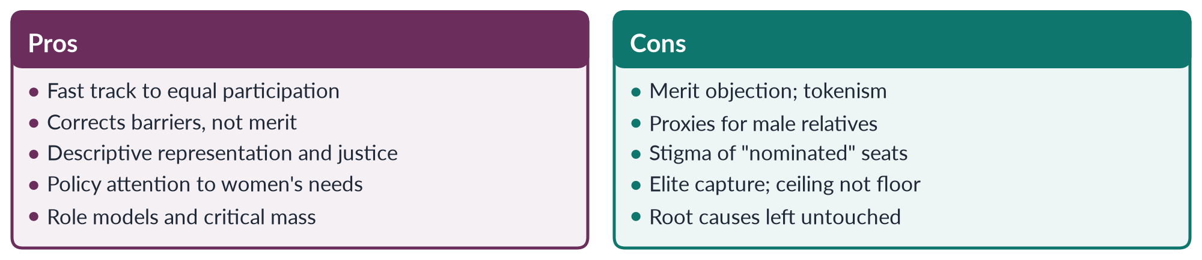
Figure 2 · The case for and against gender quotas.

10. Impact in Pakistan — the gains

i) Numbers
Since the Legal Framework Order 2002, women hold 60 National Assembly seats, 17 in the Senate and 128 (now 132) in the provinces; under the Devolution Plan (2000–01) about 36,000 women became councillors.

ii) Laws
Women legislators, organised in the cross-party Women's Parliamentary Caucus (2008), drove the workplace harassment law (2010), the acid and anti-women practices laws (2011), the NCSW Act (2012) and the honour-killing and anti-rape laws (2016).

iii) Agenda
Domestic violence, harassment and inheritance became normal business of the assemblies; monitoring groups such as FAFEN found women members among the most active in moving questions, resolutions and private members' bills.

11. Impact in Pakistan — the limits
Reserved seats are filled from party lists, so members owe their place to leaders and rarely defy them. Only 11 women won general seats in 2024, and parties give women few winnable tickets despite the 5% rule. In 2025 there were no women federal ministers. Reserved-seat women lack constituencies and development funds, and local quotas have been cut since 2013. Many reserved seats have gone to relatives of party leaders, confirming the proxy criticism, and the stigma of being "nominated" persists in debates on the floor of the House.

12. My view, reforms and conclusion

i) My view
The quota has achieved descriptive and partly substantive representation; its weakness lies in its design, not its principle. The lesson of the 1990s — when the quota lapsed and women almost vanished from parliament — is that Pakistan cannot yet do without it.

ii) Reforms
Move towards direct election of women's seats; raise the candidate quota and require winnable seats; impose sanctions; give all members equal resources; restore 33% local quotas.

iii) Conclusion
Quotas have real costs, but the alternative — near-exclusion, as in the 1990s — is worse. Pakistan's quota has brought women into the assemblies and produced landmark laws. The next task is to turn presence into power.

Why this answer scores
- Gives both sides before judging, as "pros and cons" requires.
- Uses theory (Dahlerup, Pitkin, Kanter) and evidence (India, Sweden, Pakistan's 1990s).
- Gives a clear personal view on Pakistan, backed by laws and data.
- A compare figure sets out the debate at a glance.

Answer 2 · Women's Political Participation, Democracy and Development in Pakistan (CSS 2017)
AT A GLANCE · CSS 2017 · Q4 · 20 MARKS
'Women's active political participation could stabilize democracy and boost economic development.' Comment on this statement within the context of the socio-economic realities of Pakistani society.

The answer map
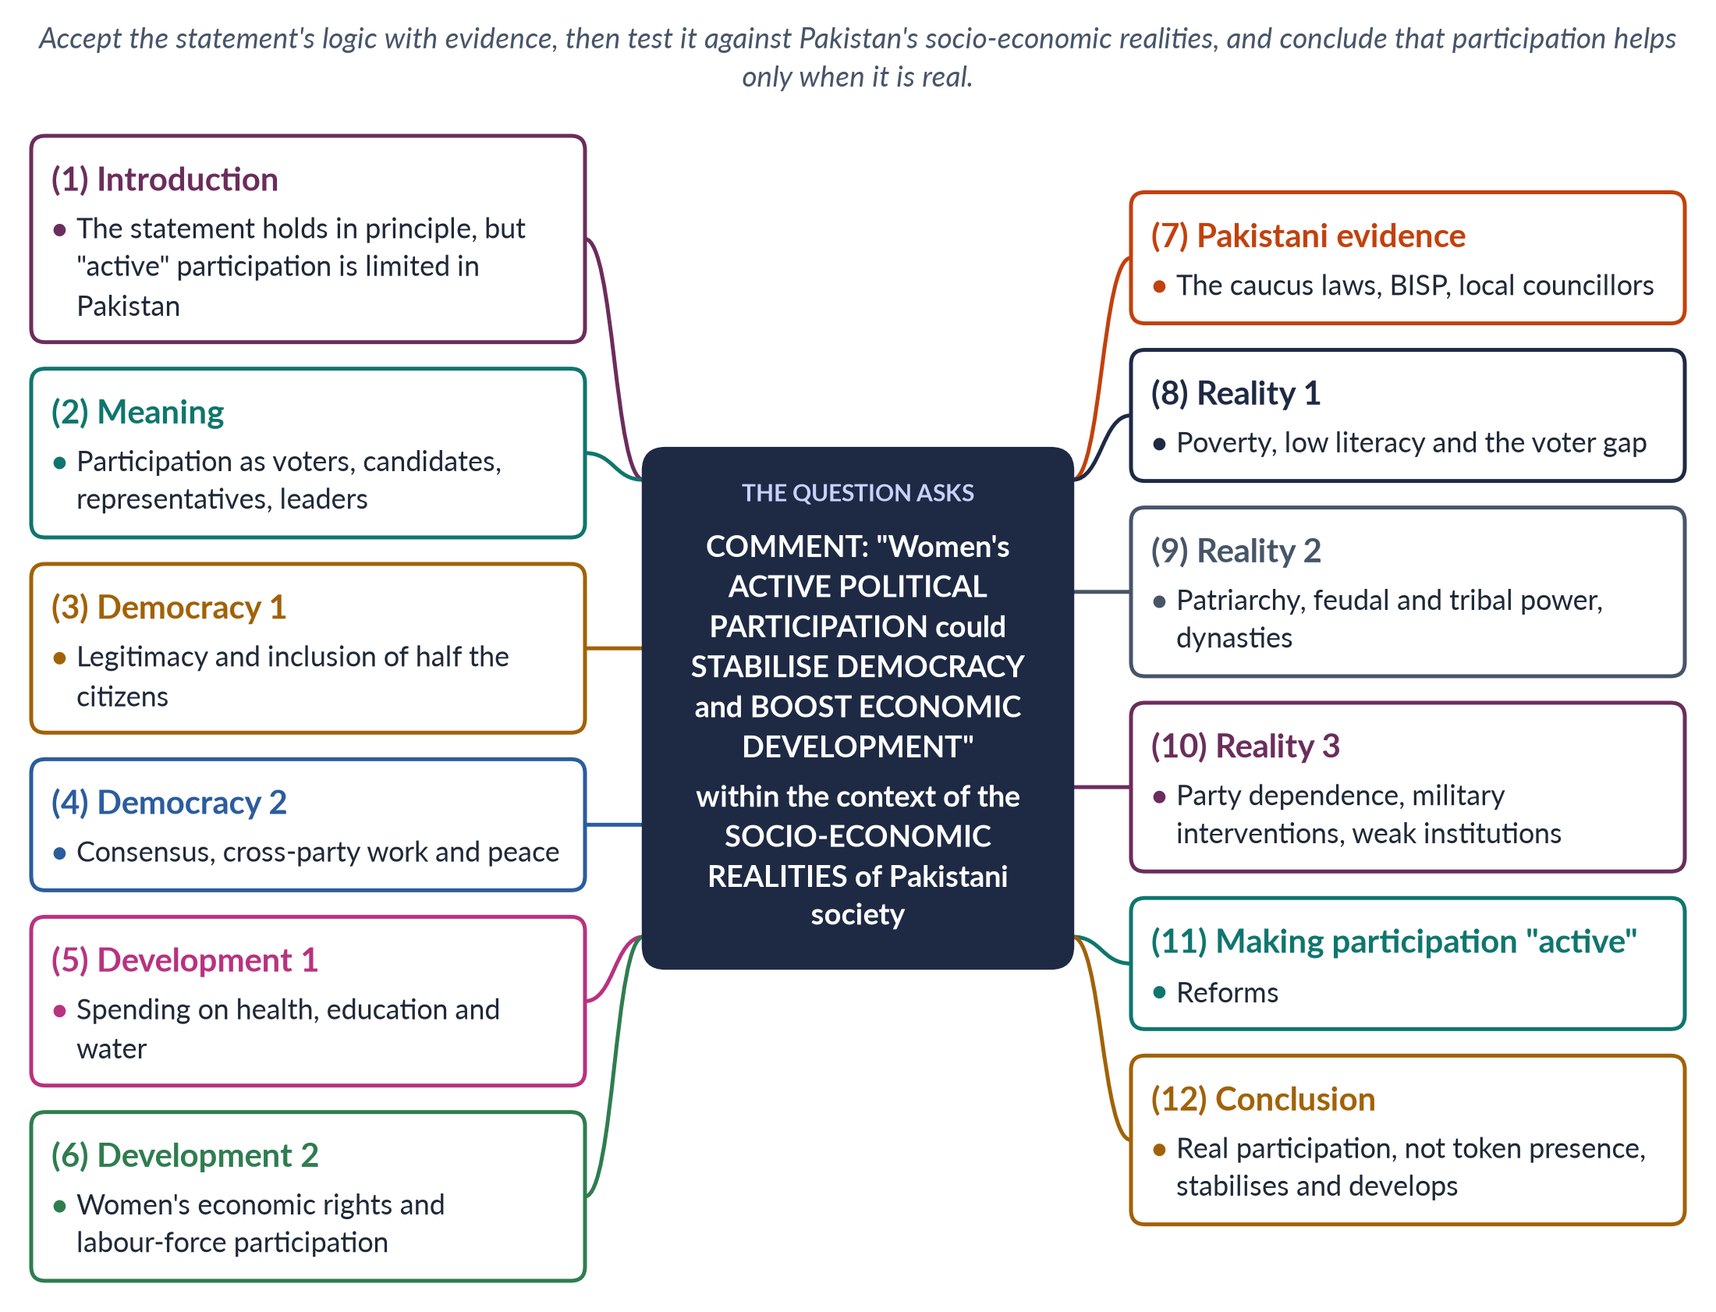
Figure 3 · The answer map: every branch is one numbered heading of the model answer below.

Decoding the question
"Comment" asks for your judgement on the statement, with reasons. The statement makes two claims — women's participation stabilises democracy and boosts development — so test both. "Within the context of the socio-economic realities of Pakistani society" means you must show which Pakistani conditions help or limit this potential. Note the word active: token presence is not enough.

The model answer

1. Introduction

i) Definition
Political participation means taking part in public affairs — voting, campaigning, contesting elections, representing and leading.

ii) The argument
The statement is true in principle and supported by evidence: women's participation makes democracy more legitimate and inclusive, and directs spending towards health, education and women's work. But in Pakistan, socio-economic realities — poverty, patriarchy, feudal power, dynasties and party control — keep women's participation more nominal than active. The potential will be realised only if participation becomes real.

2. What women's participation means in Pakistan
Women are about half of Pakistan's 241 million people. In 2024 they were 46.1% of registered voters, voted at about 43% against 52% for men, and won 11 general National Assembly seats, alongside 60 reserved seats. Participation is "active" when women vote by their own choice, contest elections, debate and shape policy — not merely when they are counted on the roll or placed on a party list.

3. Democracy 1: legitimacy and inclusion
A democracy that excludes half its citizens is incomplete. Women's presence makes parliament more representative and more trusted, and gives women a stake in the system. The UDHR (Article 21) and CEDAW (Article 7) treat participation as a right; a state that respects it is more legitimate. When women see themselves represented, they are more likely to trust institutions, use the courts and complain through lawful channels — all signs of a stable democracy.

4. Democracy 2: consensus, cross-party work and peace

i) Cross-party work
In a polarised parliament, the Women's Parliamentary Caucus (2008) has been one of the few bodies in which members of all parties cooperate.

ii) Peace and stability
Research behind UN Security Council Resolution 1325 (2000) suggests peace agreements last longer when women take part. Women's networks often bridge divides. In Pakistan, women legislators from rival parties have jointly moved bills and resolutions on violence, harassment and inheritance — rare moments of consensus in a confrontational system.

5. Development 1: spending priorities
Women representatives tend to give priority to health, education, water and nutrition — investments with high economic returns. Healthy, educated mothers raise healthier, better-educated children, so these choices pay off across generations. In India, women village leaders chosen by quota invested more in drinking water (Chattopadhyay and Duflo, 2004).

6. Development 2: women's economic rights
Women's laws help women enter and stay in work: the workplace harassment law (2010), the Sindh Home-Based Workers Act (2018), the Enforcement of Women's Property Rights Act (2020) and maternity leave rules. Female labour-force participation is only 24.4% (LFS 2024–25); raising it would add greatly to national income. International studies have estimated that closing gender gaps in work could raise the GDP of countries like Pakistan by a large margin; women legislators have been the main advocates of the laws that make this possible.
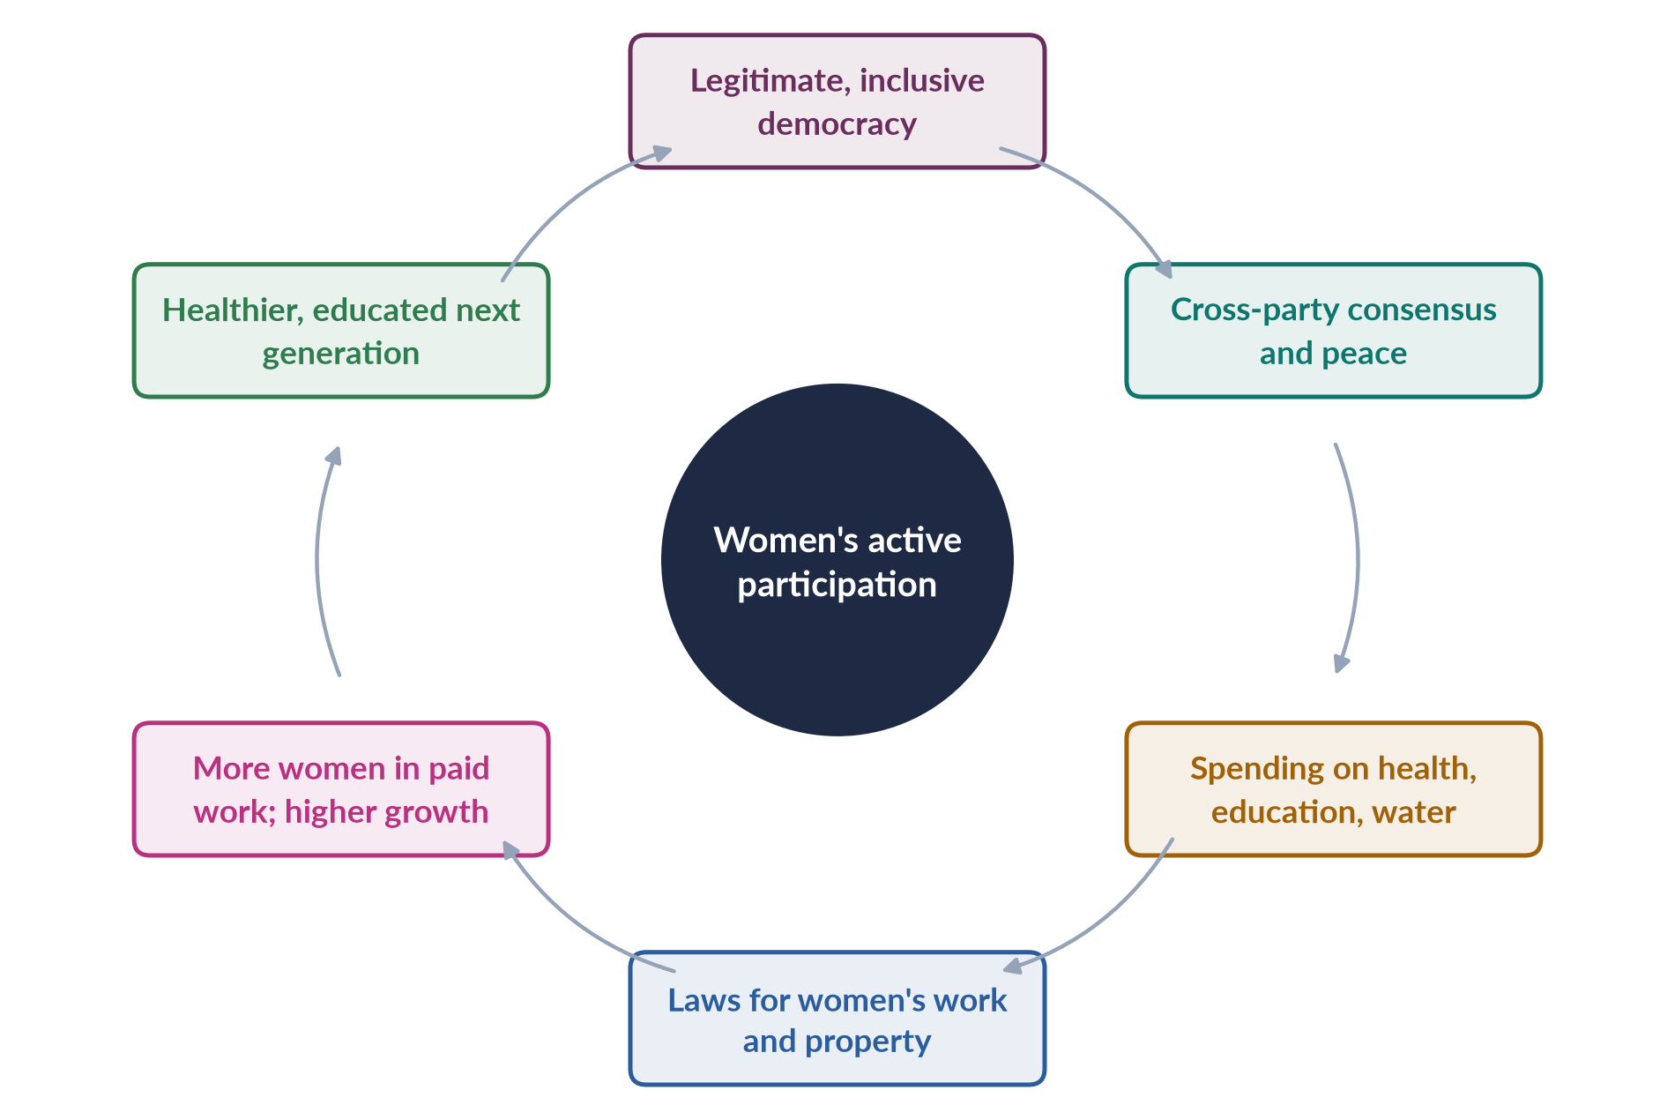
Figure 4 · How active participation by women can strengthen democracy and development.

7. Pakistani evidence
The pro-women laws of 2010–2016, passed in assemblies with 60-plus women members, show the substantive impact of participation. The Benazir Income Support Programme (2008), paid to women, was championed by women in government and reached millions of poor households. The women councillors of 2001 raised water, schools and health in local councils.

An example from the assemblies
The Senate bill against honour killings, moved by Senator Sughra Imam in 2014, shows women legislators acting for women — and for the rule of law. After the murder of Qandeel Baloch in 2016, women members across parties pressed until a joint sitting passed the law in October. Such cross-party action is exactly the kind of consensus that strengthens democratic institutions.

8. Reality 1: poverty, literacy and the voter gap

i) Poverty and literacy
Female literacy is about 53% (Census 2023). Poor, uneducated women have little time, information or confidence to engage in politics. Many cannot read ballot papers or party manifestos, and depend on male relatives for political information.

ii) The voter gap
In 2024 there were 9.94 million fewer women than men on the electoral roll, mainly because many women lack identity cards.

9. Reality 2: patriarchy, feudal power and dynasties

i) Patriarchal norms
Purdah and family honour limit women's mobility; many women vote as husbands or elders decide; some local agreements have barred women from voting.

ii) Feudal and tribal power
Landlords and biradari networks control votes and tickets. In such areas, a woman's vote is often negotiated as part of a family or clan bloc, and women candidates without such backing stand little chance.

iii) Dynasties
Many women in politics come from political families, so their participation can reinforce elite power rather than open politics to ordinary women.

10. Reality 3: parties, interruptions and institutions

i) Party dependence
Reserved-seat women are chosen by party leaders and must follow party lines.

ii) Military interventions
Democracy itself has been interrupted repeatedly, limiting the growth of stable institutions. Ironically, the two largest expansions of women's seats — 1985 and 2002 — came under military rulers, which allowed critics to call them cosmetic.

iii) Weak implementation
Laws passed by women are poorly enforced — police, courts and local officials often ignore them. In 2025 there were no women federal ministers, so women had little say over the economic decisions that most affect development.

11. Making participation "active"
1. Register every woman — free, mobile CNIC drives linked to BISP and health cards; enforce the 10% women's turnout rule (Elections Act 2017, Section 9).
2. Direct election of women's seats and a stronger candidate quota in winnable seats.
3. Party democracy — women in party executives and ticket committees.
4. Local government with 33% women's seats as a training ground.
5. Girls' education and women's work — the socio-economic base of participation.
6. Safety — action against harassment and violence, online and offline.
7. Equal resources — development funds, offices and committee roles for all women members, so that they can deliver for their voters.

12. Conclusion
The statement is right: women's participation can stabilise democracy by making it legitimate and consensual, and boost development by redirecting resources and protecting women's work. Pakistan's women legislators have already shown this. But in Pakistan's socio-economic reality, participation is often nominal. Only when it becomes active — independent, resourced and widespread — will its promise be fulfilled. Investing in women's political voice is therefore an investment in both a steadier democracy and a stronger economy.

Why this answer scores
- Tests both claims — democracy and development — with evidence.
- Applies the statement to Pakistan's socio-economic realities, as the question requires.
- Picks up the key word "active" and builds the argument around it.
- A cycle figure shows the causal chain.

Answer 3 · "Women Hold Up Half the Sky": Do We Need Equal Numbers of Women in Public Life? (CSS 2018)
AT A GLANCE · CSS 2018 · Q7 · 20 MARKS
Believing in the statement that 'women cover half the sky', do you think we need an equal number of women in all spheres of the public domain, especially in politics?

The answer map
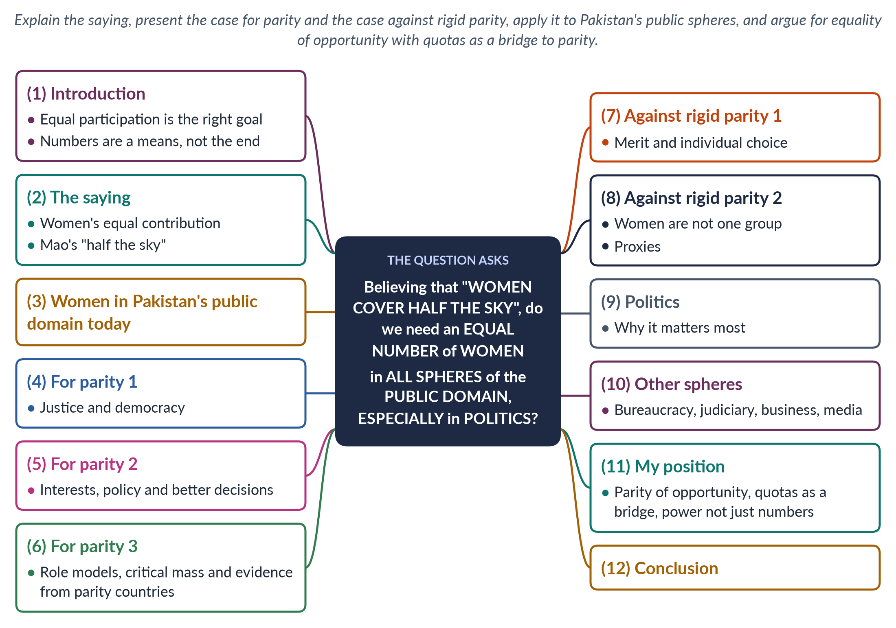
Figure 5 · The answer map: every branch is one numbered heading of the model answer below.

Decoding the question
"Do you think" asks for your opinion, argued with reasons on both sides. The question has two scopes: "all spheres of the public domain" (bureaucracy, judiciary, business, media) and "especially politics" — so give politics most space. Explain the saying "women cover (hold up) half the sky" in the introduction.

The model answer

1. Introduction

i) The saying
"Women hold up half the sky", a saying associated with Mao Zedong, means that women contribute equally to society and should therefore share equally in its decisions.

ii) The argument
I agree that women should have an equal share of public life, especially politics — justice, democracy and better policy all demand it. But equal numbers should be treated as a goal reached through equal opportunity, with quotas as a bridge, not as a rigid formula imposed overnight. Numbers must also come with real power.

2. The meaning of the saying
Women do half — often more than half — of society's work, paid and unpaid. If they "hold up half the sky", excluding them from decisions is both unjust and wasteful. The idea underlies SDG target 5.5, which calls for women's full and effective participation and equal opportunities for leadership at all levels. The Beijing Platform for Action (1995), Critical Area G, likewise called for gender balance in power and decision-making.

3. Women in Pakistan's public domain today
Women are about half of the population but roughly one-fifth of the National Assembly, mostly on 60 reserved seats; only 11 won general seats in 2024. In 2025 there were no women federal ministers. Women hold a 10% quota in federal jobs but few senior posts, and remain a tiny share of the police; Justice Ayesha Malik became the first woman Supreme Court judge only in 2022.
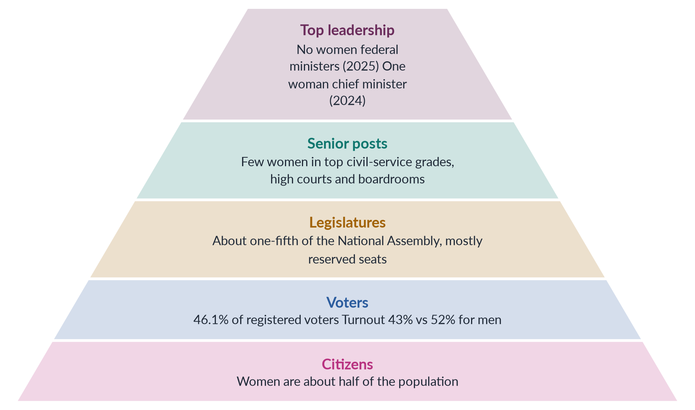
Figure 6 · Women's presence narrows at each level of public life in Pakistan.

4. For parity 1: justice and democracy
Political equality is a human right — UDHR Article 21, CEDAW Article 7, Pakistan's Articles 25 and 34. Quaid-e-Azam Muhammad Ali Jinnah told students at Aligarh in 1944 that no nation can rise to the height of glory unless its women are side by side with its men. A democracy in which half the citizens hold a fifth of the seats is not fully representative. Hanna Pitkin's idea of descriptive representation holds that legislatures should broadly resemble the people.

5. For parity 2: interests and better decisions

i) Interests
Women's experiences — of care, maternity, violence and work — differ from men's. Anne Phillips (1995) argued that these issues reach the agenda only when women are present.

ii) Better decisions
Diverse bodies consider a wider range of problems and solutions, and are less prone to "group-think"; research on company boards and committees points the same way.

iii) Evidence
Pakistan's women legislators drove the harassment law (2010) and the honour-killing law (2016); in India, women village leaders invested more in drinking water.

6. For parity 3: role models and proof that it works

i) Role models
Women in office change ideas of who can lead and raise girls' aspirations.

ii) Critical mass
Below about 30%, women remain tokens (Kanter, 1977).

iii) Parity in practice
France adopted a parity law in 2000; Rwanda's parliament is over 60% women; Nepal's 2015 constitution requires one-third, and women won about 35% of its House in 2026.

iv) In simple words
If half the passengers on a bus are women but only men are allowed to drive, decide the route and set the fares, the journey will be planned around men's needs. Parity simply means that women, who are half the passengers, also share the steering wheel. It does not push men out of the driver's seat; it ends the unwritten rule that only men may sit there. Shared driving makes for a safer journey for everyone.

7. Against rigid parity 1: merit and choice
Critics argue that posts should go to the most able, whatever their sex, and that a fixed 50% rule may promote less qualified people. Some women may choose not to enter politics because of care duties or personal preference; forcing equal numbers ignores choice. A rigid 50% rule could also be hard to fill in some fields and regions in the short term, leaving seats empty or filled by unprepared nominees.

8. Against rigid parity 2: women are not one group
Women differ by class, religion, region and party. A woman legislator from a landed family may not represent poor rural women. Where parties control selection, forced parity may produce proxies — wives and daughters of male politicians — rather than independent women. Numbers alone, without independence, would give the appearance of equality without its substance.

9. Politics — why it matters most
Politics is the sphere where laws, budgets and priorities are set for all other spheres, and where the state's commitment to equality is either honoured or ignored. Women's presence in politics shapes education, health, employment and justice. That is why the question says "especially" politics, and why quotas are most widely used there. Pakistan's own experience shows the difference: the laws on harassment, acid attacks, anti-women practices and honour killing came only after women's numbers rose to about a fifth of parliament.

10. Other spheres of the public domain
- Bureaucracy: the 10% job quota is unfilled at senior levels; women are needed in district administration and police.
- Judiciary: women judges improve access to justice for women in family and violence cases, where many women hesitate to speak before men.
- Business and boards: listed companies must have at least one woman director; Norway's 40% board quota (2003) shows stronger options.
- Media and academia: women shape public debate and knowledge.

11. My position

i) Equal opportunity first
Remove barriers — party gatekeeping, money, harassment, lack of childcare and mobility.

ii) Quotas as a bridge
Use quotas to reach a critical mass (at least 33%) and move towards parity, as Nepal has.

iii) Power, not just numbers
Women must hold ministries, committee chairs and senior posts, and be directly elected, so that equal numbers mean equal influence. Diversity among women — rural, minority and working-class women — should also be sought, so that parity represents all women, not only the elite.

12. Conclusion
If women hold up half the sky, they should share half the decisions. Equal participation in all public spheres — above all in politics — is the right goal, demanded by justice and supported by evidence. Pakistan, with women at about a fifth of parliament and absent from the 2025 cabinet, is far from it. The way forward is equal opportunity, with quotas as a bridge and real power as the test.

Why this answer scores
- Explains the saying and links it to SDG 5.5.
- Weighs both sides and gives a clear, reasoned opinion.
- Covers "all spheres" but gives politics most weight, as asked.
- A pyramid figure shows how women's presence narrows at each level.

Answer 4 · Short Note: The Suffragist Movement (CSS 2019)
AT A GLANCE · CSS 2019 · Q8(A) · 10 MARKS
Write short notes on any TWO: Suffragist movement

The answer map
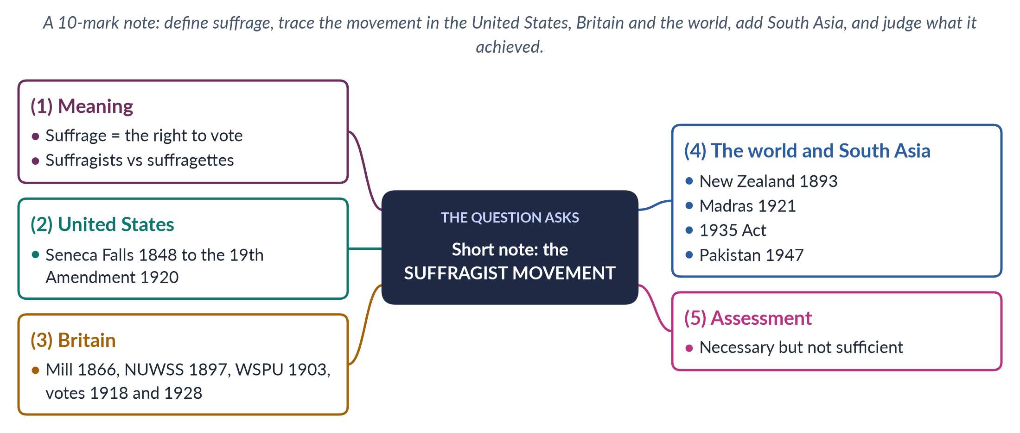
Figure 7 · The answer map for the short note: every branch is one headed point.

Decoding the question
A short note of 10 marks: about 550–650 words. Define suffrage, distinguish suffragists from suffragettes, give the key dates and leaders in the United States and Britain, add the wider world and South Asia, and end with a brief assessment.

The model answer

1. Meaning
Suffrage means the right to vote. The suffragist movement was the organised campaign of the nineteenth and early twentieth centuries to win women the vote on equal terms with men — the central demand of first-wave feminism. Suffragists used peaceful, lawful methods; suffragettes — a name the Daily Mail gave in 1906 to militant British campaigners — used direct action. Opponents argued from "separate spheres" and coverture; suffragists replied with natural rights, democracy ("no taxation without representation") and the claim that women would bring care and morality to public life. Mary Wollstonecraft's A Vindication of the Rights of Woman (1792) had laid the intellectual groundwork.

2. The United States
The movement began at the Seneca Falls Convention (1848), organised by Elizabeth Cady Stanton and Lucretia Mott, whose Declaration of Sentiments declared that "all men and women are created equal" and demanded the vote. After the 15th Amendment (1870) enfranchised Black men but not women, the movement split into the National Woman Suffrage Association (Stanton and Susan B. Anthony, 1869) and the American Woman Suffrage Association (Lucy Stone). They united as NAWSA in 1890. Western states such as Wyoming (1869) led the way; Alice Paul's pickets kept up pressure; and the 19th Amendment (1920) gave women the vote nationwide — though many Black women in the South were kept from voting until the Voting Rights Act of 1965.

3. Britain
John Stuart Mill presented a women's suffrage petition to Parliament in 1866 and wrote The Subjection of Women (1869). Millicent Fawcett's NUWSS (1897) campaigned peacefully; Emmeline Pankhurst's WSPU (1903) adopted the motto "Deeds, not words" — window-smashing, arson and hunger strikes, met by force-feeding and the "Cat and Mouse Act" (1913). Emily Wilding Davison died after the Epsom Derby in 1913. After women's war work, the Representation of the People Act (1918) enfranchised women over 30 with property, and the Equal Franchise Act (1928) gave women the vote at 21, on equal terms with men.
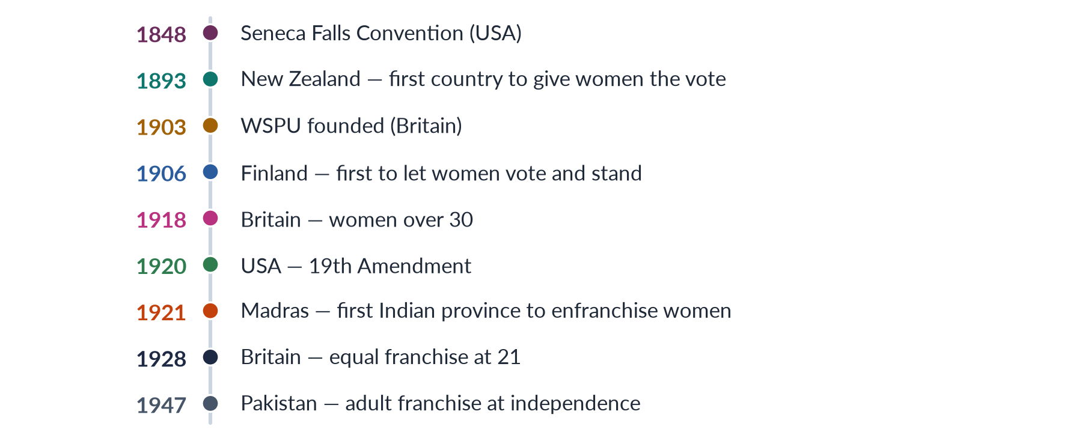
Figure 8 · Milestones of women's suffrage.

4. The world and South Asia
New Zealand (1893), after Kate Sheppard's petitions, was the first country to give women the vote; Finland (1906) was the first to let them stand for parliament. In colonial India, the Women's Indian Association and Sarojini Naidu demanded the vote in 1917; Madras enfranchised women in 1921; and the Government of India Act 1935 extended the vote to about six million women and reserved seats for them. Pakistan began with adult franchise in 1947, and Fatima Jinnah contested the presidency in 1965; its first Constituent Assembly had two women — Jahanara Shahnawaz and Shaista Ikramullah.

Why the vote mattered
The vote gave women a lever over legislators: within a few years of enfranchisement, parliaments in Britain and the United States began passing laws on women's property, child custody, maternity and working conditions, because politicians now needed women's votes.

5. Assessment
The movement won women the vote and the right to stand across most of the world, and trained generations of women in organising. But many suffragists were white and middle-class; Black women in the American South and working-class women in Britain were left behind; and the vote did not end discrimination at home, at work or in law — which led to the second wave. In Pakistan, women have voted since 1947, yet in 2024 there were still 9.94 million fewer women than men on the electoral roll. Suffrage was necessary but not sufficient: the right to vote opened the door, but registration, freedom to choose and the right to be elected had still to be won — the agenda of governance today.

Why this answer scores
- Defines suffrage and distinguishes suffragists from suffragettes.
- Gives accurate dates and leaders for the United States and Britain.
- Adds the world and South Asia, including Pakistan — rarely done.
- Ends with a balanced assessment in a compact note.

Answer 5 · Should Women "Pull Each Other Up" into Leadership? (CSS 2020)
AT A GLANCE · CSS 2020 · Q5 · 20 MARKS
Women need to be in leadership positions to pull more women into leadership roles. Is this suggestion that women need to 'pull each other up' useful, or is it inappropriate preferential treatment?

The answer map
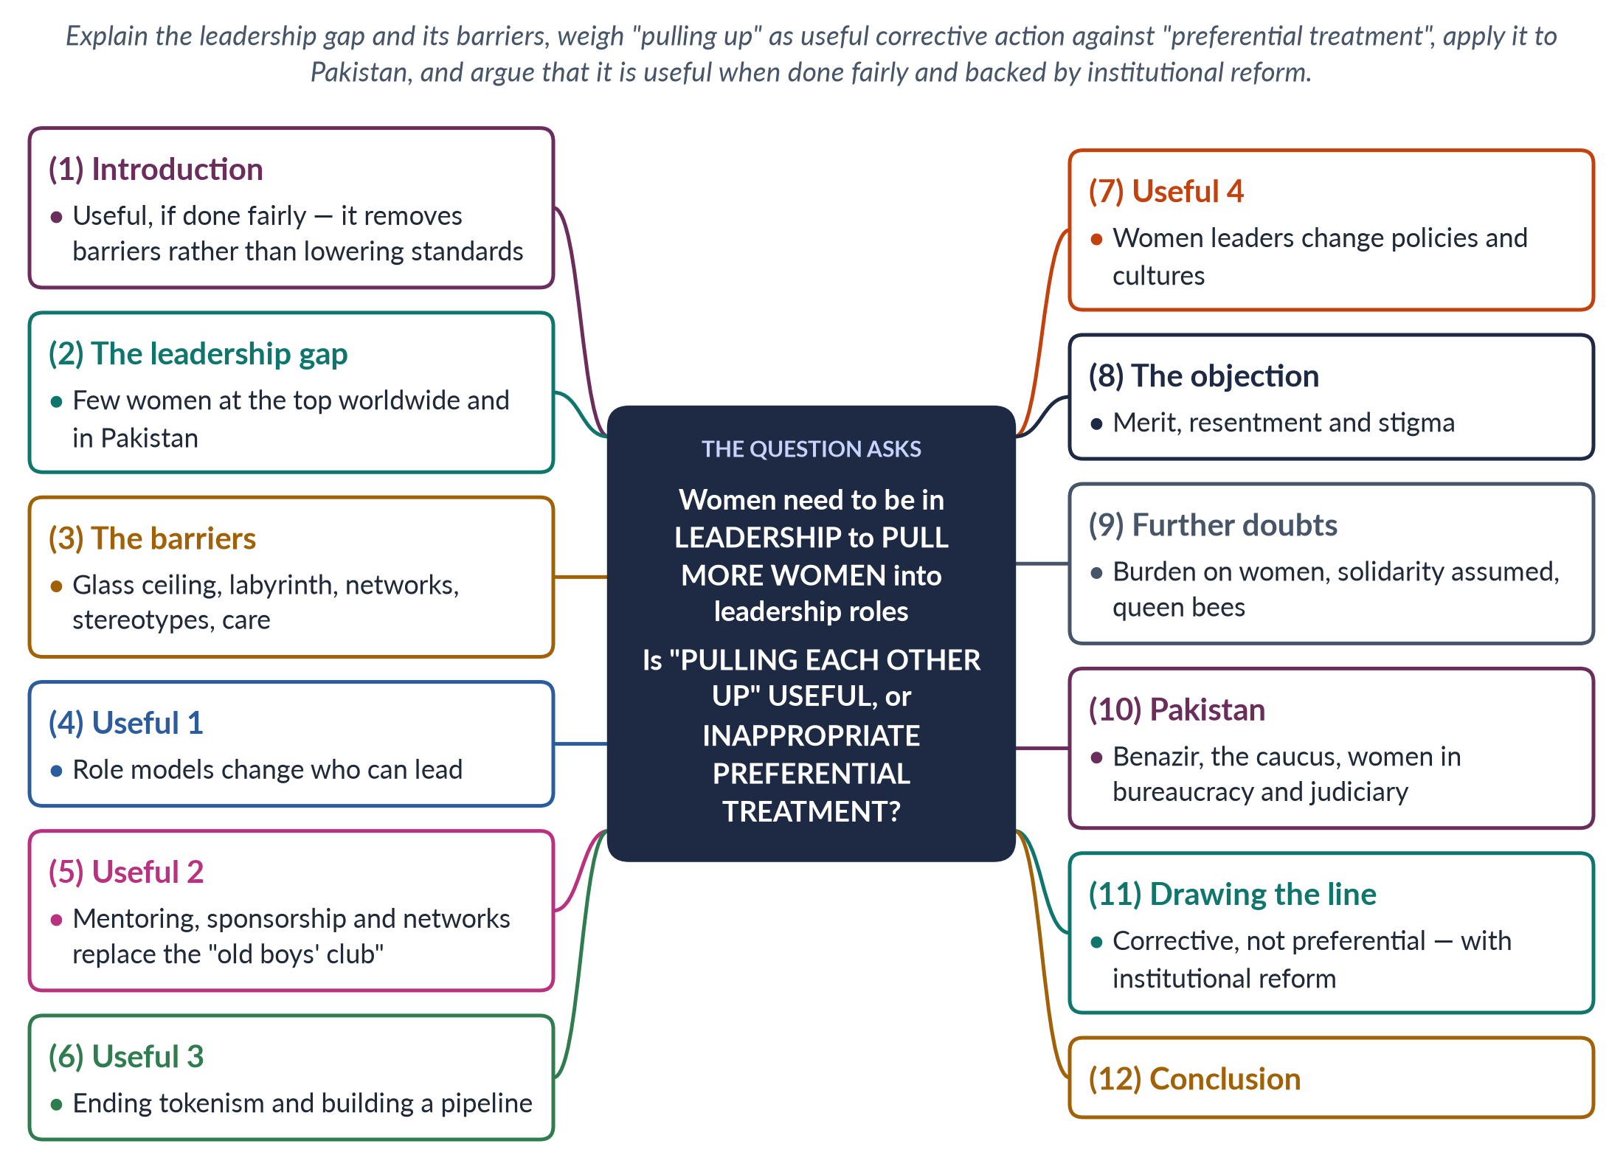
Figure 9 · The answer map: every branch is one numbered heading of the model answer below.

Decoding the question
The question sets up a debate: is the idea that women leaders should help other women rise useful, or is it inappropriate preferential treatment? You must explain why women are scarce in leadership, give both sides, and reach a reasoned judgement. Use the concepts glass ceiling, tokenism, mentoring and sponsorship, and Pakistani examples.

The model answer

1. Introduction

i) Definition
"Pulling each other up" means women in leadership using their position to help other women rise — as role models, mentors, sponsors and makers of fairer rules.

ii) The argument
This is useful, not preferential, when it means removing barriers within fair, transparent procedures. It replaces the informal help men have always given one another. It becomes inappropriate only if women are appointed because they are women regardless of ability. It works best when backed by institutional reform, so that women's progress does not depend on a few individuals.

2. The leadership gap
Worldwide, women are a minority of heads of government, cabinet ministers, judges and chief executives. In Pakistan, Benazir Bhutto (1988) and Maryam Nawaz (2024) broke barriers, but in 2025 there were no women federal ministers, and women remain rare in senior civil-service grades, the higher judiciary and boardrooms. Women are often a majority of medical and many university graduates, so the gap at the top is not a gap in talent but a gap in opportunity — what researchers call the leaky pipeline.

3. The barriers

i) Glass ceiling and labyrinth
Invisible barriers stop women at the top; Eagly and Carli (2007) described a labyrinth of obstacles throughout women's careers.

ii) Networks
Men benefit from informal "old boys' networks" that pass on information and opportunities — in clubs, families, alumni circles and party hierarchies. Nobody calls this preferential treatment, yet it has favoured men for generations.

iii) Stereotypes and the double bind
Leadership is seen as "masculine"; assertive women are disliked, gentle women dismissed.

iv) Care and culture
Long hours, travel and care duties penalise women; harassment pushes them out. In Pakistan, family expectations after marriage add a further barrier.

4. Useful 1: role models
Visible women leaders show that leadership is possible — what one cannot see, one finds hard to become. In India, after villages had women leaders under quotas, voters' bias fell and girls' aspirations for education and careers rose (Beaman and colleagues, 2012).

5. Useful 2: mentoring, sponsorship and networks

i) Mentoring
Advice and encouragement build confidence, skills and knowledge of how institutions really work.

ii) Sponsorship
Actively recommending women for posts matters even more for promotion.

iii) Networks
Women's caucuses and associations give women the connections men already have. This levels the field; it does not tilt it. Studies of corporate careers have found that women are often over-mentored but under-sponsored — given advice but not the backing of a senior person who puts their name forward.
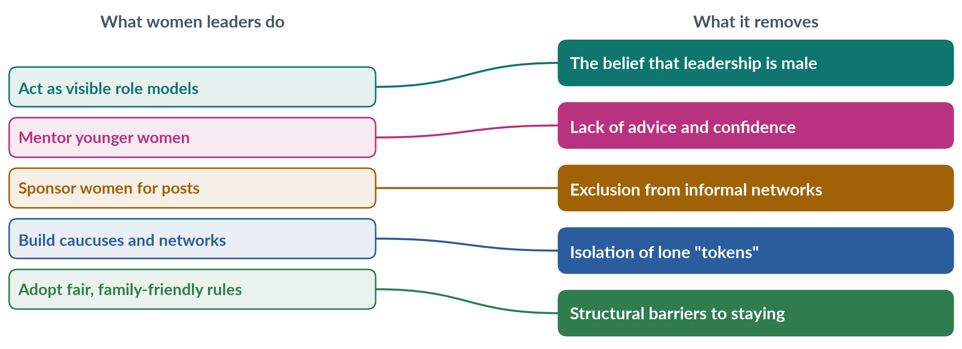
Figure 10 · How women leaders "pull each other up" — and what each step removes.

6. Useful 3: ending tokenism and building a pipeline
Rosabeth Moss Kanter (1977) showed that women who are under about 15% of a group are "tokens" — highly visible, isolated and pressured to conform. Bringing in more women reduces this pressure and creates a pipeline of qualified successors. Once women are a critical mass — about 30% — their presence is no longer remarkable, and they are judged as individuals rather than as representatives of their sex.

7. Useful 4: changing policies and cultures
Women leaders often introduce anti-harassment rules, childcare and flexible work, which help both women and men. Such changes keep talented women from leaving mid-career and benefit the whole institution. Pakistan's Women's Parliamentary Caucus (2008), in which women of all parties supported one another, produced the harassment law (2010) and later laws on acid attacks, anti-women practices and honour killing.

An example
When Benazir Bhutto became prime minister in 1988, she appointed women to posts such as judges of the higher courts and set up women's police stations and the First Women Bank (1989), creating openings that women had not had before. These steps did not lower standards; they opened doors that had been closed, and many of the women who walked through them later rose on their own merit to senior positions. Opening a door is not the same as carrying someone through it.

8. The objection: merit, resentment and stigma
Critics argue that helping someone because she is a woman may pass over more able candidates, and that colleagues may assume women rose through favour rather than ability — a stigma that harms all women, including those who succeeded on merit. In a country where recruitment is often accused of nepotism, any appearance of favouritism can damage public trust in institutions.

9. Further doubts

i) An unfair burden
Expecting women leaders to "lift" others places a duty on them that men do not carry.

ii) Solidarity assumed
Women differ by class, party and ideology; a woman leader is not obliged to favour women, and voters judge her on her whole record, not on gender alone.

iii) Queen bees
Some senior women distance themselves from junior women — the "queen bee" pattern described in 1974. Later research links this to male-dominated cultures, which shows why institutional change matters.

10. The Pakistani experience
Benazir Bhutto inspired a generation, created women's police stations (1994) and appointed women judges, but faced the double bind and opposition from those who said a woman could not lead a Muslim state. Women's caucuses show the power of solidarity. In the civil service, a 10% job quota and growing numbers of women passing the CSS examination are filling the pipeline, but few reach the top. Justice Ayesha Malik (2022) became the first woman Supreme Court judge, and Tehmina Janjua (2017) the first woman foreign secretary — each a role model whose visibility encourages younger women to aim higher.

11. Drawing the line

i) Useful
Mentoring, sponsoring, networking, role modelling and fair rules — within transparent, merit-based procedures.

ii) Inappropriate
Appointing women only because they are women, without regard to ability, or excluding men unfairly.

iii) Institutional reform
The surest safeguard against favouritism is fair recruitment and promotion — open advertisements, mixed selection panels and published criteria. Add quotas where barriers are entrenched, plus childcare and the enforcement of anti-harassment rules, so that women's progress does not depend on the goodwill of individuals.

12. Conclusion
"Pulling each other up" is not preferential treatment; it is corrective action that gives women what men's networks have long given men. Done fairly, it reduces tokenism, builds a pipeline and changes institutions. Pakistan's women leaders and caucuses show its value — and the absence of women from the 2025 cabinet shows how much remains to be done.

Why this answer scores
- Explains why the gap exists before judging the suggestion.
- Gives both sides and draws a precise line between useful and inappropriate help.
- Uses theory (Kanter, Eagly and Carli) and evidence (India, Pakistan's caucus).
- A mapping figure shows how "pulling up" removes specific barriers.

Answer 6 · Is Pakistan's Gender Quota Showing Results? Quotas and Political Mainstreaming (CSS 2021)
AT A GLANCE · CSS 2021 · Q8 · 20 MARKS
Despite the entry of women legislators into politics on a 17 percent quota in national and provincial assemblies, there are still voices asking, 'Is Pakistan's gender quota in parliament showing results?' Rethink and discuss how quotas can lead to the political mainstreaming of women in Pakistan.

The answer map
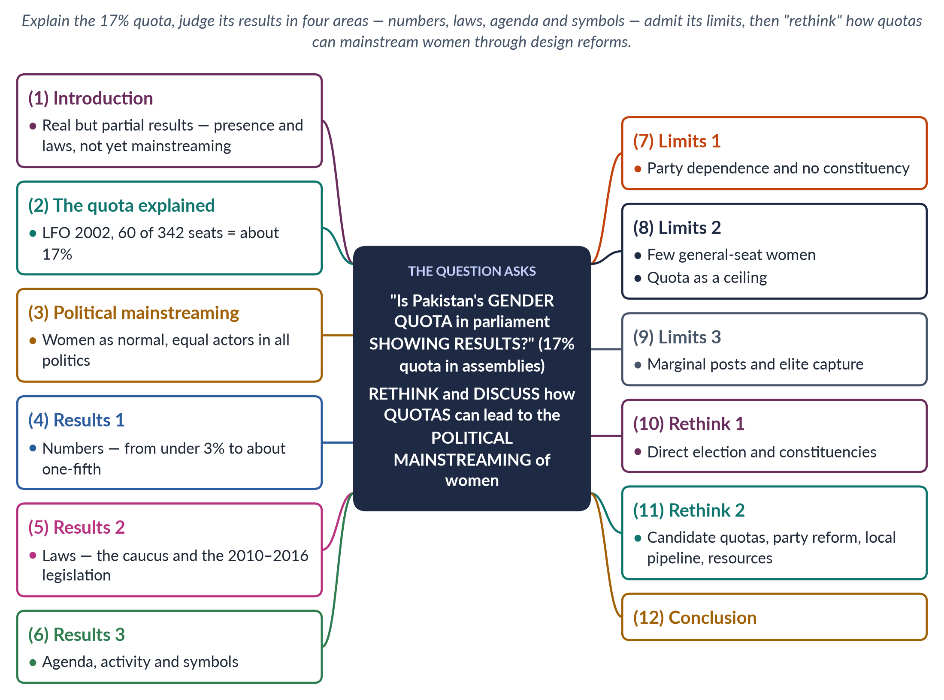
Figure 11 · The answer map: every branch is one numbered heading of the model answer below.

Decoding the question
The question quotes a sceptical voice — "Is the quota showing results?" — and then asks you to "rethink and discuss" how quotas can lead to political mainstreaming. So: (1) explain the 17% quota; (2) judge its results with evidence; (3) admit its limits; (4) propose reforms that turn the quota into mainstreaming. "Mainstreaming" means women becoming normal, equal actors in all of politics, not a separate group.

The model answer

1. Introduction

i) Definition
A gender quota reserves a minimum share of seats or candidacies for women. Political mainstreaming means that women take part in all areas of politics — general seats, cabinets, party leadership, every policy field — as equals, not as a reserved minority.

ii) The argument
Pakistan's quota is showing results: it has raised women's numbers, produced landmark laws and changed the agenda. But it has not yet produced mainstreaming, because reserved-seat women depend on party leaders and few women win general seats. A rethought quota — directly elected, combined with strong candidate quotas and party reform — can make women part of the mainstream.

2. The quota explained
The Legal Framework Order 2002 (validated by the 17th Amendment, 2003) enlarged the National Assembly to 342 seats and reserved 60 for women — about 17% — plus 17 Senate seats and 128 provincial seats. These are filled by proportional representation from party lists, each party receiving women's seats in proportion to the general seats it wins in each province. After the 2018 merger of the tribal areas, the Assembly has 336 seats, still with 60 for women.

3. What mainstreaming requires
Mainstreaming would mean women winning general seats, holding major ministries, leading parties and shaping all policy — finance and security as well as social welfare. The test of a quota is whether it leads there, or keeps women in a separate box. The concept echoes gender mainstreaming, adopted at the Beijing conference (1995): gender should be part of all decisions, not a side issue handled by a women's ministry.

4. Results 1: numbers
In the 1990s, when reserved seats had lapsed, only two to six women sat in the National Assembly. Since 2002, women have held about one-fifth of seats. The Devolution Plan (2000–01) added about 36,000 women councillors. This is the "fast track" that Drude Dahlerup described — a jump to near-critical mass within a single election, which decades of gradual change had failed to produce.

5. Results 2: laws
The cross-party Women's Parliamentary Caucus (2008) turned numbers into legislation:
- the workplace harassment law and Section 509 PPC (2010);
- the Acid Control and Prevention of Anti-Women Practices laws (2011), both private members' bills by women;
- the NCSW Act (2012);
- the anti-honour-killing and anti-rape laws (2016);
- provincial domestic-violence laws (2013–2021).

6. Results 3: agenda, activity and symbols

i) Agenda
Violence, harassment and inheritance became normal business of parliament, discussed in debates, questions and standing committees rather than dismissed as private family matters.

ii) Activity
Monitoring by FAFEN and PILDAT found women members among the most active in questions, resolutions and bills, with good attendance — evidence against the claim that they are passive tokens.

iii) Symbols
Women legislators, a woman Speaker (Fahmida Mirza, 2008) and a woman chief minister (Maryam Nawaz, 2024) have changed ideas of who can govern.
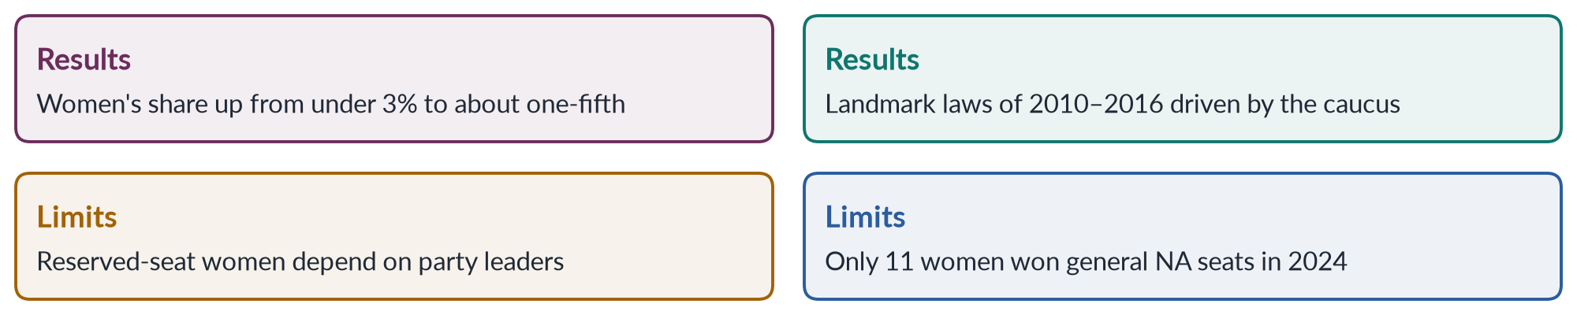
Figure 12 · The results of Pakistan's quota — and its limits.

iv) In simple words
The quota opened the door of the assemblies to women; it has not yet given them the keys to the rooms where the most important decisions are made — the cabinet, the finance committee and the party's ticket board. Mainstreaming means handing over those keys too — through direct election, winnable tickets and a fair share of cabinet and committee posts, including the powerful ministries of finance, interior and foreign affairs. Until then, women remain present in the assemblies but peripheral to power.

7. Limits 1: party dependence and no constituency
Reserved seats are filled from party lists, so women owe their seats to party leaders and rarely defy them. They have no constituency, so they lack a power base, development funds and a route to general seats. Few reserved-seat women have later won a general seat, so the quota rarely acts as a stepping stone. The stigma of being "nominated" persists. The 2024–25 legal dispute over whether PTI-backed independents should receive a share of reserved seats showed that these seats depend wholly on party arithmetic, not on women's own standing with voters.

8. Limits 2: few general seats; quota as a ceiling
Only 11 women won general National Assembly seats in 2024 — about 4% of 266. Parties treat reserved seats as women's share and give men nearly all winnable tickets. The 5% ticket rule of the Elections Act 2017 is weak, and women are often placed in losing constituencies.

9. Limits 3: marginal posts and elite capture
Women ministers usually receive "soft" portfolios such as women's development or social welfare, rarely finance, interior or foreign affairs; in 2025 there were none at federal level. Many list places go to relatives of party leaders, so poor, rural and minority women remain unrepresented. Local quotas were also cut after 2013 under new provincial laws, weakening the pipeline that the 2001 reform had created.

10. Rethink 1: direct election and constituencies
1. Rotating reserved constituencies, as in India's panchayats, would let voters elect women directly.
2. Dual-member constituencies with one woman member are another option.
3. Either would give women a constituency, legitimacy and independence from party leaders.
4. Reserved-seat members could at least be assigned districts to serve, with equal development funds, as an interim step.

11. Rethink 2: candidate quotas, party reform, pipeline and resources

i) Stronger candidate quotas
Raise the 5% rule (towards 33%) and require women in winnable seats, with sanctions.

ii) Party reform
Quotas in party executives and ticket committees; transparent list selection through internal party elections, so that list places reward work rather than family ties.

iii) Local pipeline
Restore 33% women's seats in local government as a training ground, and encourage successful councillors to contest provincial and national general seats.

iv) Equal resources and roles
Equal development funds, offices, committee chairs and cabinet posts, including major ministries.

v) Lessons from Nepal
Nepal's 2015 constitution and PR lists produced about 35% women in 2026; India's rotating panchayat seats have brought over a million women into directly elected local office. Both show that design, not culture, determines results.

12. Conclusion
The sceptics are only half right. Pakistan's quota has shown results — more women, landmark laws and a changed agenda. What it has not done is mainstream women into general seats, cabinets and party leadership. Rethinking its design — direct election, strong candidate quotas, party democracy and equal resources — would turn a reserved minority into equal participants.

Why this answer scores
- Explains the 17% quota accurately (60 of 342, LFO 2002).
- Judges results in several areas with evidence, and admits limits.
- Answers "rethink" with concrete design reforms and a regional comparison.
- A grid figure sets results against limits.

Answer 7 · The Main Issues Faced by Women as Representatives in Pakistan (CSS 2022)
AT A GLANCE · CSS 2022 · Q5 · 20 MARKS
In your opinion, what are the main issues faced by women as representatives in Pakistan?

The answer map
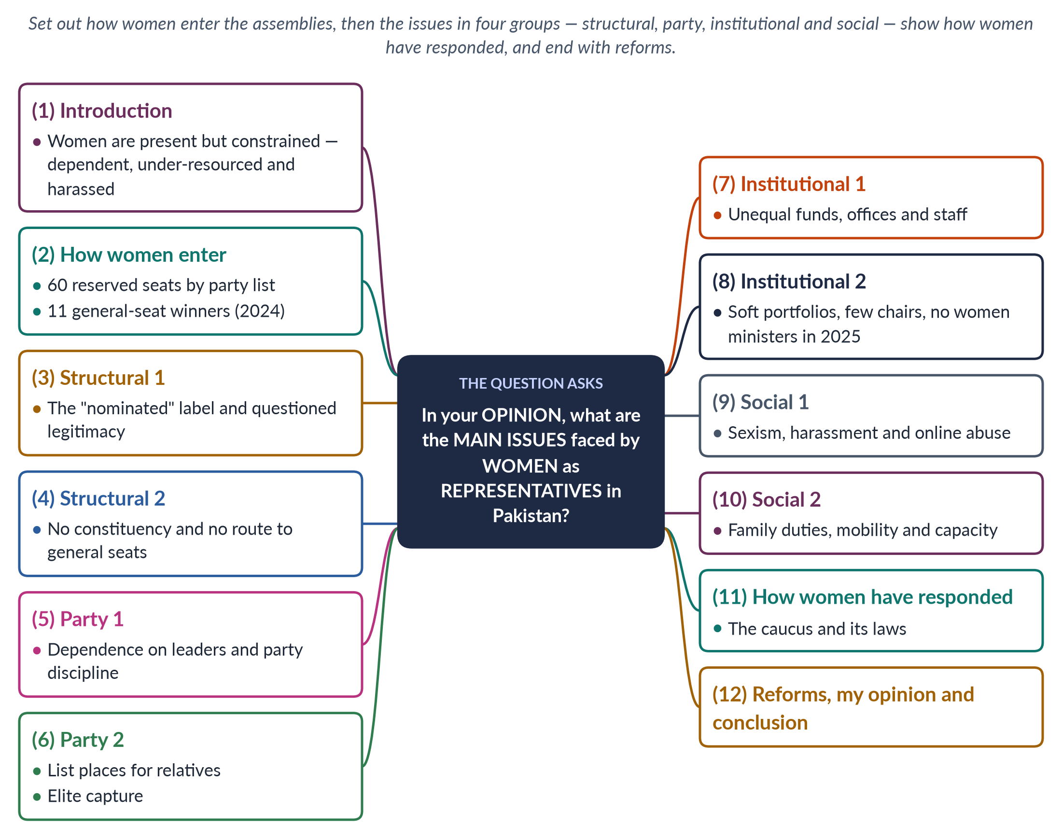
Figure 13 · The answer map: every branch is one numbered heading of the model answer below.

Decoding the question
"In your opinion" invites a personal but reasoned view. "Main issues" means the most important problems women legislators face after entering the assemblies — not only barriers to entry. Group them clearly (structural, party, institutional, social), give Pakistani evidence, and end with reforms.

The model answer

1. Introduction

i) Definition
Women representatives are women who sit in elected bodies — the National Assembly, Senate, provincial assemblies and local councils — to act for citizens.

ii) The argument
In my opinion, the main issue is that women in Pakistan's assemblies are present but not powerful. Because most enter through party-list reserved seats, they depend on party leaders, lack constituencies and resources, and face sexism. Yet they have achieved a great deal — which shows how much more they could do if these issues were addressed.

2. How women enter the assemblies
The National Assembly has 336 seats, including 60 reserved for women, filled by proportional representation from party priority lists. Only 11 women won general seats in 2024. The Senate has 17 women's seats, and the provinces 132. Women thus hold roughly one-fifth of the National Assembly — but most hold reserved seats. The way they enter shapes almost every issue they face once inside.

3. Structural issue 1: questioned legitimacy
Because reserved-seat women are not directly elected, colleagues, the media and the public often call them "nominated" members. Male legislators have at times dismissed their views on the floor of the House. This stigma undermines their authority and makes them cautious. It also lets opponents dismiss women's bills as the work of members who "did not win" — even when those bills address serious problems such as acid attacks or honour killings.

4. Structural issue 2: no constituency
Reserved-seat women have no constituency — no voters to serve, no local base to build, and no clear way to show performance. They therefore find it hard to win a general seat later. The quota keeps them in a separate category rather than moving them into the mainstream. A woman who serves two or three terms on a reserved seat may still have no local organisation to fight a general election.

5. Party issue 1: dependence and discipline
A woman's place on the party list — and so her seat — depends on the party leader. Members who defy the party risk losing their place at the next election. This limits their ability to push women's issues against party lines. When a party leader opposes a reform — or simply does not prioritise it — women members usually stay silent rather than risk their future. The 2024–25 dispute over whether reserved seats should go to PTI-backed independents showed how completely the seats depend on party arithmetic.

6. Party issue 2: relatives and elites
List places often go to wives, daughters and sisters of party leaders, or to loyal workers' families. Most women legislators are educated, urban and well-off; poor, rural and minority women are rarely represented. This elite capture weakens women legislators' claim to speak for all women. Rural women, home-based workers and religious-minority women — whose problems are most acute — have very few voices of their own in the assemblies.
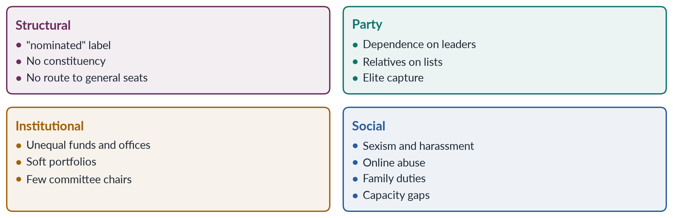
Figure 14 · The main issues faced by women representatives in Pakistan.

7. Institutional issue 1: unequal resources
Women members — especially on reserved seats — have often received smaller shares of development funds, fewer staff and less office support than male members with constituencies. Without resources they cannot deliver visible results — a school, a road, a clinic — which feeds the perception that they are ineffective and weakens their case for a general-seat ticket.

8. Institutional issue 2: marginal roles

i) Soft portfolios
Women ministers usually receive women's development, social welfare or education, rarely finance, interior, defence or foreign affairs (Hina Rabbani Khar, foreign minister in 2011, was an exception).

ii) Committees
Few women chair the most powerful standing committees, such as finance, interior or public accounts, where budgets and oversight are decided.

iii) Cabinet
The Global Gender Gap Report 2025 recorded no women federal ministers.

9. Social issue 1: sexism and harassment
Women legislators have faced sexist remarks in the assemblies, comments on their appearance and character, and abuse in the media. Online harassment — trolling, doctored images and threats — has become a major problem since social media became central to politics. Such treatment discourages women from speaking out and from entering politics at all. Disciplinary action against offending members has been rare, so the behaviour continues.

10. Social issue 2: family duties and capacity

i) Family duties
Late sessions, travel and the absence of childcare facilities make the work harder for women with families; social expectations about women's roles add pressure.

ii) Capacity
Many reserved-seat women are first-time legislators without research staff or training in drafting bills and scrutinising budgets — though parliamentary and NGO programmes have helped.

iii) An example
After the 2024 election, only 11 women won general National Assembly seats, while the 60 reserved seats were distributed according to party strength. Reserved-seat members in every province have described having to approach a male general-seat colleague to get a tube well, a school repair or a road built for the women who contact them — a daily reminder of their dependence and of their lack of an independent base.

11. How women representatives have responded
Despite these issues, women have achieved a great deal. The cross-party Women's Parliamentary Caucus (2008), formed under the first woman Speaker Dr Fahmida Mirza, drove the workplace harassment law (2010), the acid and anti-women practices laws (2011), the NCSW Act (2012) and the honour-killing and anti-rape laws (2016). Monitoring by FAFEN has found women among the most active members in questions, resolutions and private members' bills.

12. Reforms, my opinion and conclusion

i) Reforms
1. Direct election of women's seats or rotating women's constituencies.
2. Transparent party lists chosen through internal party elections.
3. Equal development funds, offices and staff for every member.
4. Women in key committees and major ministries.
5. Codes of conduct with sanctions for sexist remarks and harassment, inside the assemblies and online.
6. Day-care centres and sensible sitting hours.
7. Research support and training for new members.

ii) My opinion
The deepest issue is dependence: as long as women's seats are in the gift of party leaders, women will be present but cautious. Direct election and party democracy would do more than any other reform.

iii) Conclusion
Women representatives in Pakistan face questioned legitimacy, party dependence, unequal resources, marginal roles and sexism. That they have nevertheless passed landmark laws shows their value. Removing these obstacles would turn presence into power.

Why this answer scores
- Gives a clear personal opinion, as the question asks.
- Groups the issues into four clear categories with Pakistani evidence.
- Balances problems with achievements (the caucus laws).
- A grid figure summarises the issues for quick marking.

Answer 8 · Political Participation as a Human Right; Obstacles for Women Politicians and the Impact of Quotas (CSS 2024)
AT A GLANCE · CSS 2024 · Q7 · 20 MARKS
Is political participation a human right? If so, what obstacles are faced by women politicians in Pakistan in pursuing a career in politics? What is the impact of the political quota system on this?

The answer map
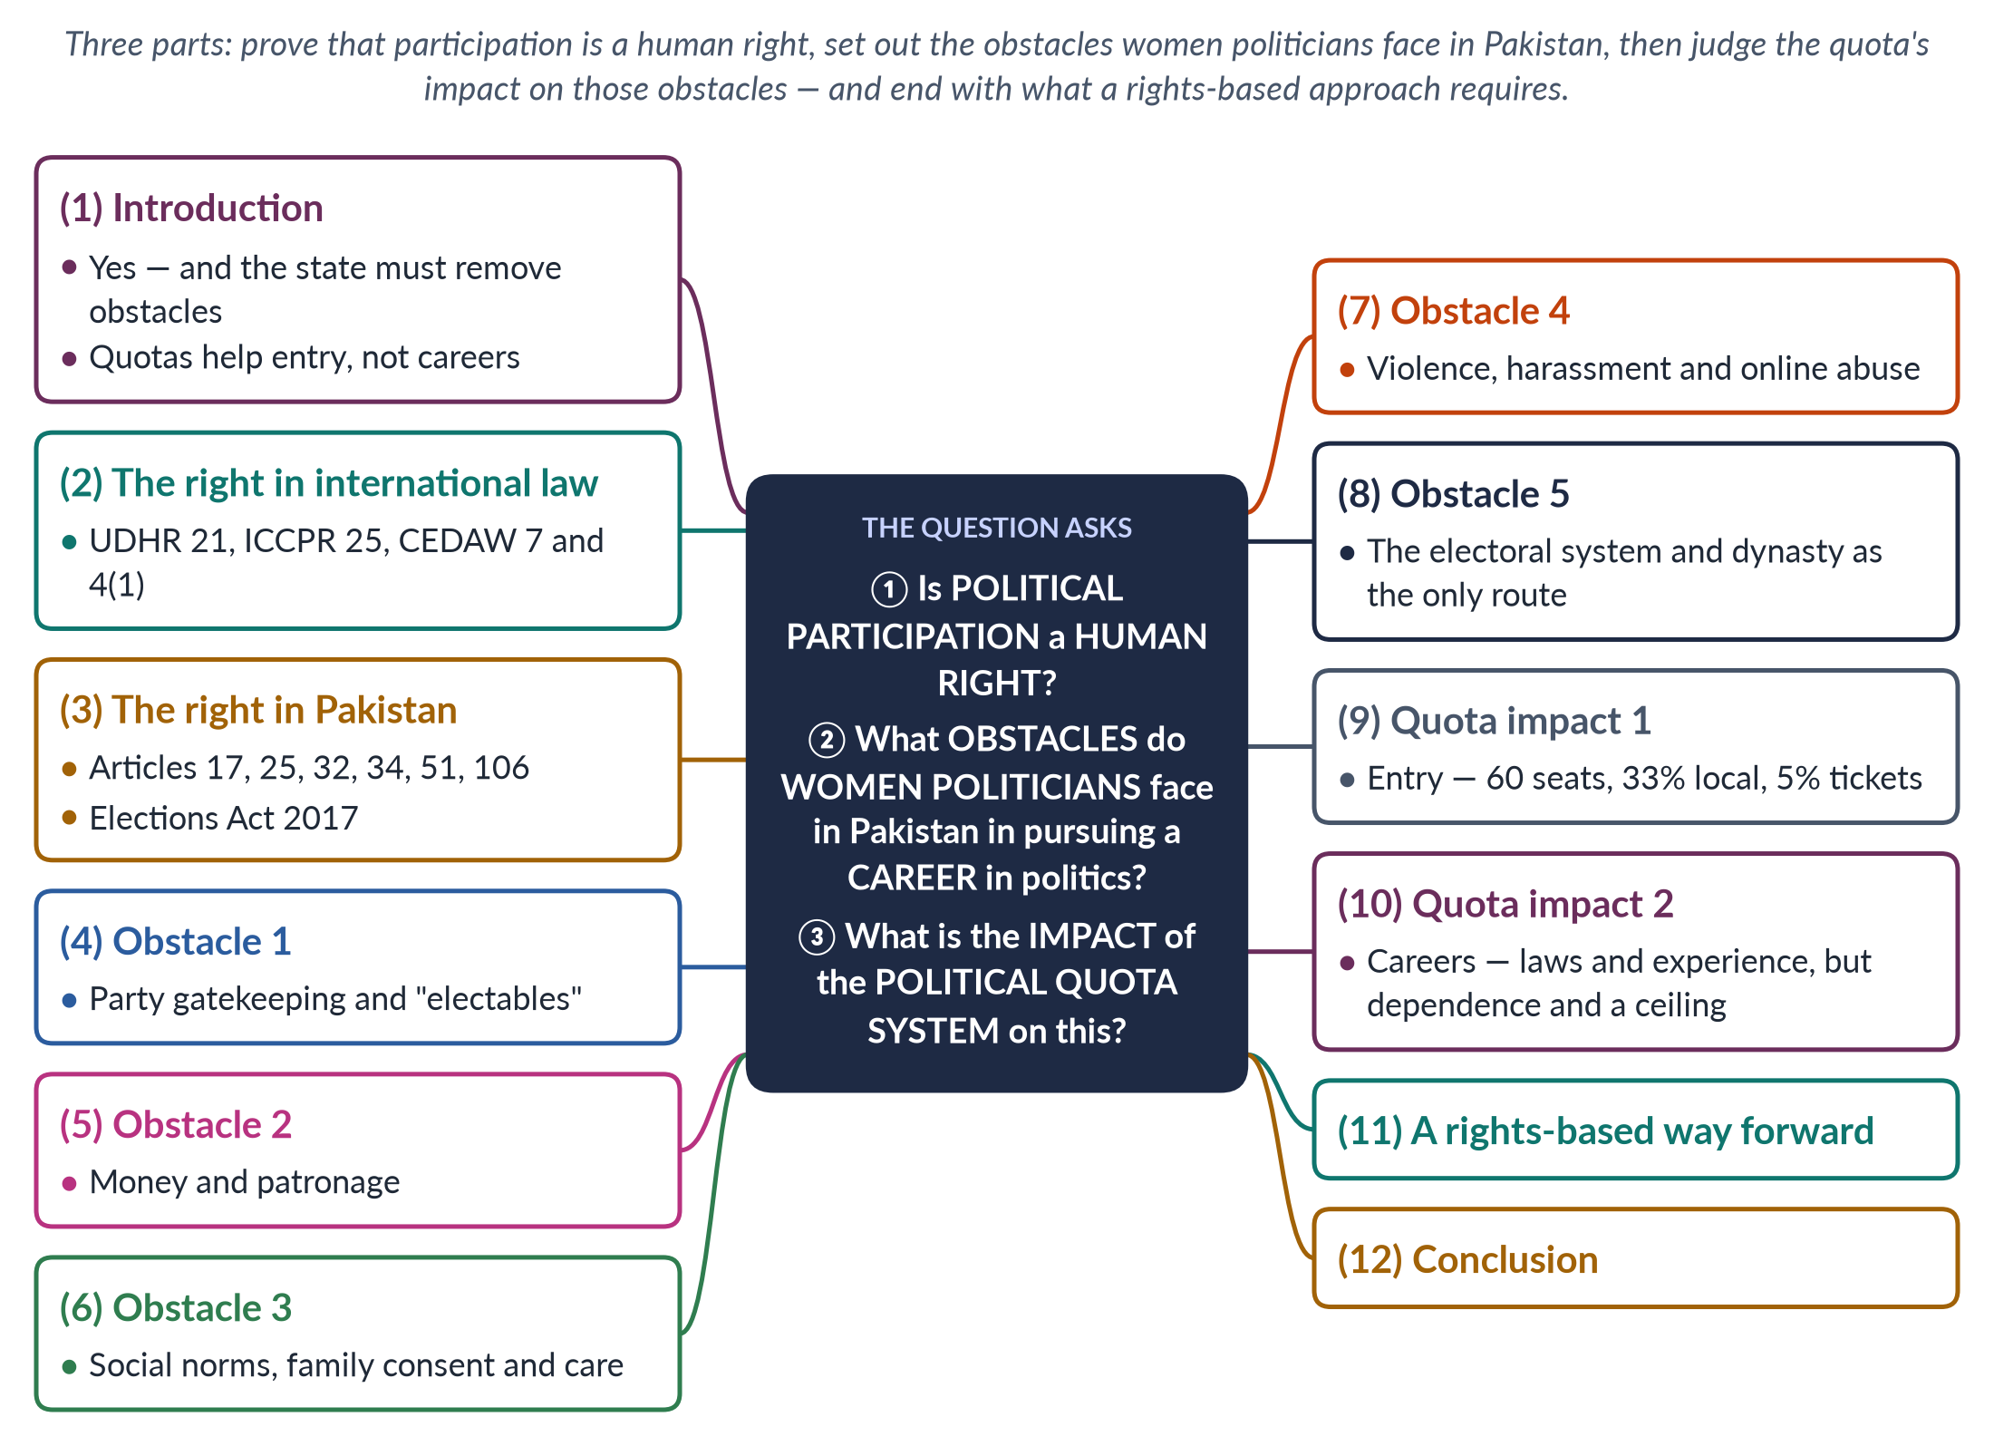
Figure 15 · The answer map: every branch is one numbered heading of the model answer below.

Decoding the question
Three linked parts. "Is political participation a human right?" needs a clear yes, proved from international law and the Constitution. "Obstacles faced by women politicians… in pursuing a career" asks about long-term careers, not only first elections. "Impact of the political quota system on this" asks how quotas affect those obstacles — positively and negatively.

The model answer

1. Introduction

i) Definition
Political participation means taking part in public affairs — voting, joining parties, contesting elections, holding office and influencing policy.

ii) The argument
Political participation is unquestionably a human right, guaranteed by international law and Pakistan's Constitution. Women politicians in Pakistan nonetheless face heavy obstacles — party gatekeeping, money, social norms, violence and the electoral system. The quota system has opened the door to entry, but because seats are in party leaders' gift, it has done less to build independent careers.

2. The right in international law
- UDHR (1948), Article 21: everyone has the right to take part in government, directly or through freely chosen representatives.
- ICCPR (1966; ratified by Pakistan in 2010), Article 25: every citizen has the right to vote, to be elected and to take part in public affairs without discrimination.
- CEDAW (1979; Pakistan 1996), Article 7: women's equal right to vote, stand for election, shape policy and hold office; Article 4(1) permits temporary special measures such as quotas.
- The UN Human Rights Committee's General Comment 25 (1996) requires states to take positive measures to overcome obstacles to participation, such as illiteracy, poverty and restrictions on movement.
- SDG target 5.5 (2015) calls for women's full participation and equal opportunities for leadership.

3. The right in Pakistan

i) The Constitution
Article 17 (freedom of association and to form or join parties), Article 25 (equality and special provision for women), Article 32 (women in local government), Article 34 (full participation of women) and Articles 51, 59 and 106 (reserved seats).

ii) The law
The Elections Act 2017 requires 5% of party tickets for women (Section 206) and lets the ECP void polls where women's turnout is below 10% (Section 9).

iii) What follows
If participation is a right, the state must not only permit women to take part but remove the obstacles that stop them. A right that half the citizens cannot use in practice is a right only on paper.

4. Obstacle 1: party gatekeeping
Parties decide tickets, and their leaderships are overwhelmingly male. They favour "electables" — men with land, money and clan support. Women are given few tickets, often in constituencies the party expects to lose. In 2024, 306 women contested general National Assembly seats and only 11 won. The 5% ticket rule says nothing about winnable seats, so parties can comply on paper while keeping women out of real contests.

5. Obstacle 2: money and patronage
Campaigns cost huge sums for rallies, transport and payments to local power brokers. Women own little land or capital and have weaker access to donors and patronage networks, so they struggle both to win and to sustain a career. Election spending limits exist in law but are widely ignored, which gives the advantage to wealthy candidates — mostly men.

6. Obstacle 3: social norms, family and care
Purdah and family honour restrict women's mobility and contact with male voters; women need family consent; and late sessions and travel clash with care duties. Women who succeed are judged on their appearance and private lives in ways men are not — the double bind of being called too weak if gentle and too harsh if firm.

7. Obstacle 4: violence and harassment
Women politicians face threats, character assassination and growing online abuse. The assassination of Benazir Bhutto in 2007 is the starkest reminder of political violence. Fear of violence deters many women from politics. Online, women politicians face doctored images and sexual slurs; the Prevention of Electronic Crimes Act (2016) offers some remedy, but enforcement is weak.

8. Obstacle 5: the system and dynasty
Under first-past-the-post, parties choose the "safest" candidate, usually a man with biradari backing. As a result, dynasty is often the only route for women: many successful women — Benazir Bhutto, Maryam Nawaz — are daughters of political families. Women without such connections find careers almost closed. Even within dynasties, women often step aside when a male relative is available, so their careers can be interrupted at the family's choice.
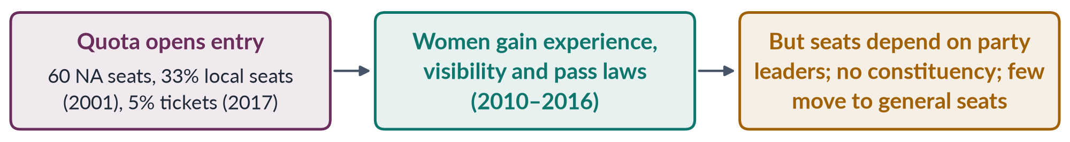
Figure 16 · How the quota system affects women's political careers.

In simple words
Saying women have the right to stand for election, while parties will not give them tickets, campaigns cost millions and opponents threaten them, is like saying everyone has the right to enter a race while only some runners are allowed shoes. A rights-based approach removes the obstacles, not just the formal bar — which is exactly what CEDAW's "temporary special measures" under Article 4(1) are meant to do. Rights must be usable, not merely written.

9. Quota impact 1: entry
The quota has transformed entry. In the 1990s, without reserved seats, only two to six women sat in the National Assembly; since the Legal Framework Order 2002, women have held about one-fifth. The Devolution Plan brought about 36,000 women into local councils in 2000–01, and the 5% ticket rule (2017) pushed parties to field more women on general seats.

10. Quota impact 2: careers

i) Positive
Quotas give women experience, visibility and networks. Women legislators formed the Women's Parliamentary Caucus (2008) and passed laws on harassment (2010), acid attacks and anti-women practices (2011) and honour killing (2016) — building records on which careers can rest.

ii) Negative
Because seats are filled from party lists, careers depend on leaders' favour; reserved-seat women lack constituencies and rarely move to general seats; parties treat the quota as a ceiling; and the "nominated" stigma persists. Few reserved-seat women rise to ministerial office; in 2025 there were no women federal ministers.

11. A rights-based way forward
1. Direct election of women's seats or rotating women's constituencies.
2. A stronger candidate quota (towards 33%) in winnable seats, with sanctions.
3. Campaign finance support and enforced spending limits.
4. Protection against violence and online harassment of women politicians.
5. Party democracy — women in party executives and ticket committees.
6. Local government quotas restored to 33% as a career pipeline.

12. Conclusion
Political participation is a human right under the UDHR, the ICCPR, CEDAW and Pakistan's Constitution. Women politicians in Pakistan nevertheless face party gatekeeping, money, social norms, violence and a system that rewards dynasty. The quota system has opened the door — women now hold about a fifth of the National Assembly and have passed landmark laws — but has not yet given them independent careers. A rights-based approach requires the state to remove these obstacles, not merely to reserve seats.

Why this answer scores
- Answers all three parts in order, with clear headings.
- Proves the right from international and constitutional law.
- Focuses on careers, not only entry, as the question asks.
- A flow figure shows the quota's double-edged impact.

Answer 9 · The Historical Context and Evolution of Women's Quota in Pakistan (CSS 2025)
AT A GLANCE · CSS 2025 · Q5 · 20 MARKS
Elaborate the historical context and evolution of women's quota in Pakistan concerning key legislation and policies that have shaped the quota system.

The answer map
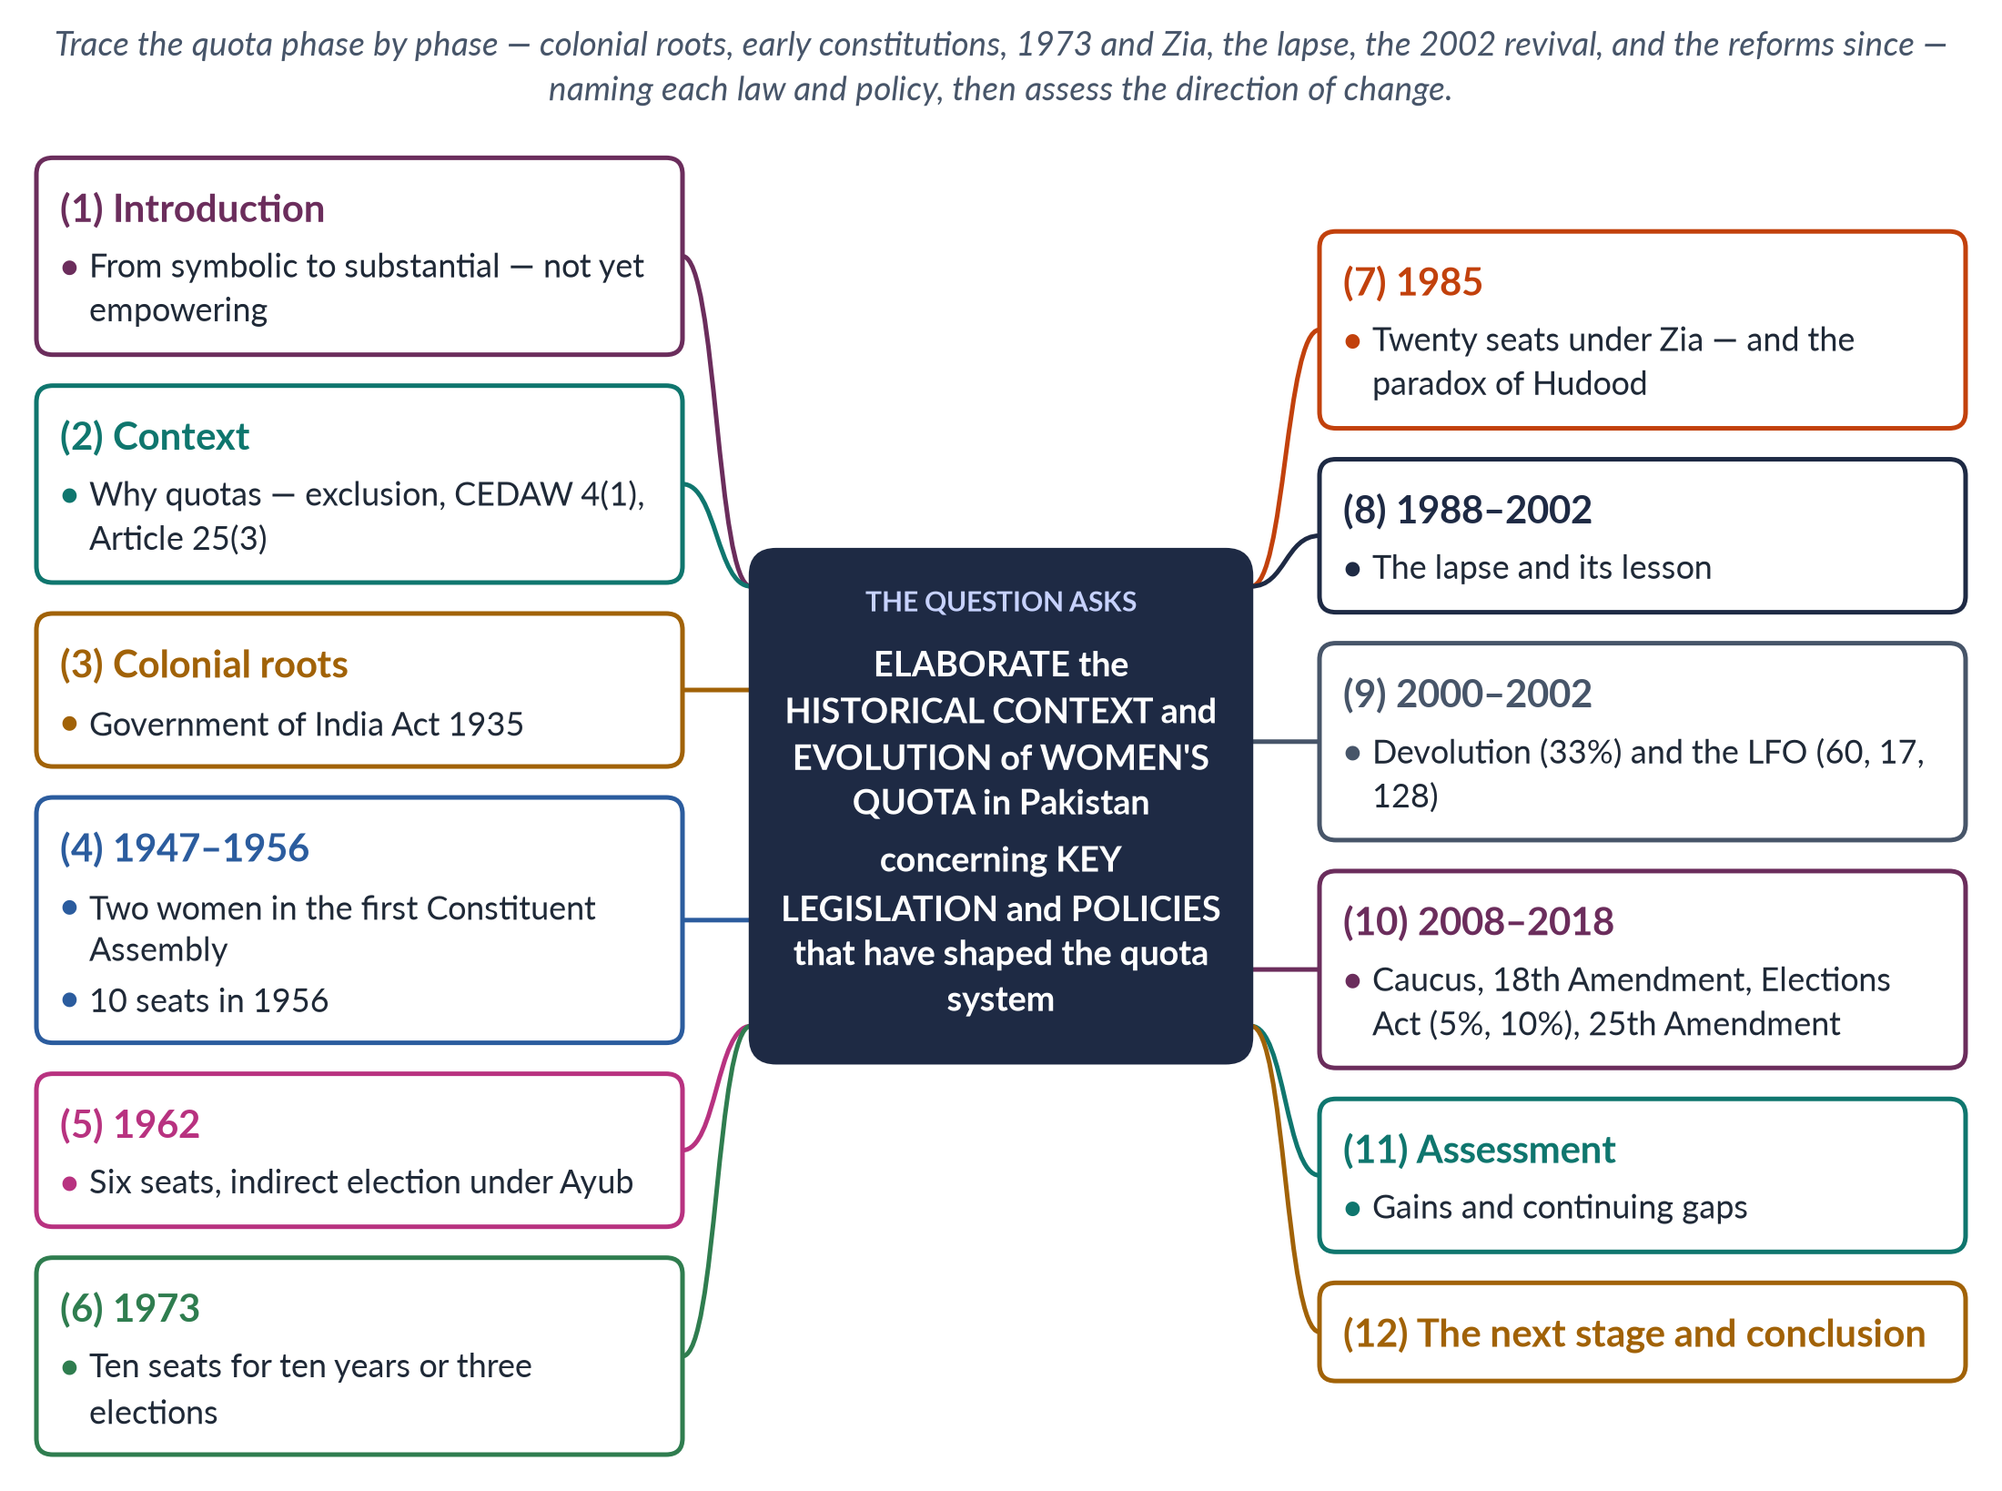
Figure 17 · The answer map: every branch is one numbered heading of the model answer below.

Decoding the question
"Elaborate" asks for a detailed explanation. "Historical context" means why quotas were adopted at each point; "evolution" means how they changed over time; "key legislation and policies" means naming the laws and orders — the 1935 Act, the constitutions of 1956, 1962 and 1973, the 1985 change, the LFO 2002, the Local Government Ordinance 2001 and the Elections Act 2017. A timeline is ideal.

The model answer

1. Introduction

i) Definition
A women's quota reserves a minimum number or share of seats, or candidacies, for women in elected bodies.

ii) The argument
Pakistan's quota has evolved from a symbolic handful of indirectly filled seats (1956–1988), through a damaging lapse (1988–2002), to a substantial system since 2002 — 60 National Assembly seats, provincial and Senate seats, and a candidate quota from 2017. It has not yet become empowering, because seats remain in party leaders' hands.

2. The context: why quotas
Women in South Asia faced exclusion from politics through purdah, low literacy, lack of property and male-dominated parties. Quotas were a way to guarantee a voice. At independence, women had played a visible part in the Pakistan Movement — in processions, the Muslim League's women's committees and refugee relief — and leaders such as Jinnah had spoken of women standing side by side with men. Internationally, CEDAW (1979, Article 4(1)) recognises temporary special measures; Pakistan's Article 25(3) allows special provision for women.

3. Colonial roots: the 1935 Act
The Government of India Act 1935 widened women's franchise (to about six million women) and reserved seats for women in the legislatures. Begum Jahanara Shahnawaz, who attended the Round Table Conferences, won a seat in the Punjab Assembly in 1937. Reserved seats came to Pakistan as part of this inheritance, and with them the habit of treating women as a separate electoral category.

4. 1947–1956: the first steps
The first Constituent Assembly (1947) had only two women — Jahanara Shahnawaz and Shaista Ikramullah. The 1956 Constitution reserved 10 seats for women — five each from East and West Pakistan — for ten years; women could also contest general seats.

5. 1962: six seats under Ayub
The 1962 Constitution of Ayub Khan reserved six seats (three per wing), filled by indirect election. In 1965 Fatima Jinnah challenged Ayub for the presidency — a reminder that women's political ambition went beyond reserved seats.

6. 1973: ten seats for a limited period
The 1973 Constitution reserved 10 National Assembly seats for women for ten years or three general elections, whichever was later, again filled indirectly, with some provincial seats. The time limit reflected the view that quotas were temporary — a bridge until women could win general seats on their own. History showed that the bridge was removed too soon.

7. 1985: twenty seats under Zia
Under General Zia-ul-Haq, women's seats were raised to 20 for the 1985 non-party election. The paradox is sharp: the same regime issued the Hudood Ordinances (1979) and the Law of Evidence (1984), which harmed women, and provoked the Women's Action Forum (1981). More seats did not mean more power: the women members of the 1985 Assembly, chosen indirectly in a non-party system, were unable to challenge the discriminatory laws.
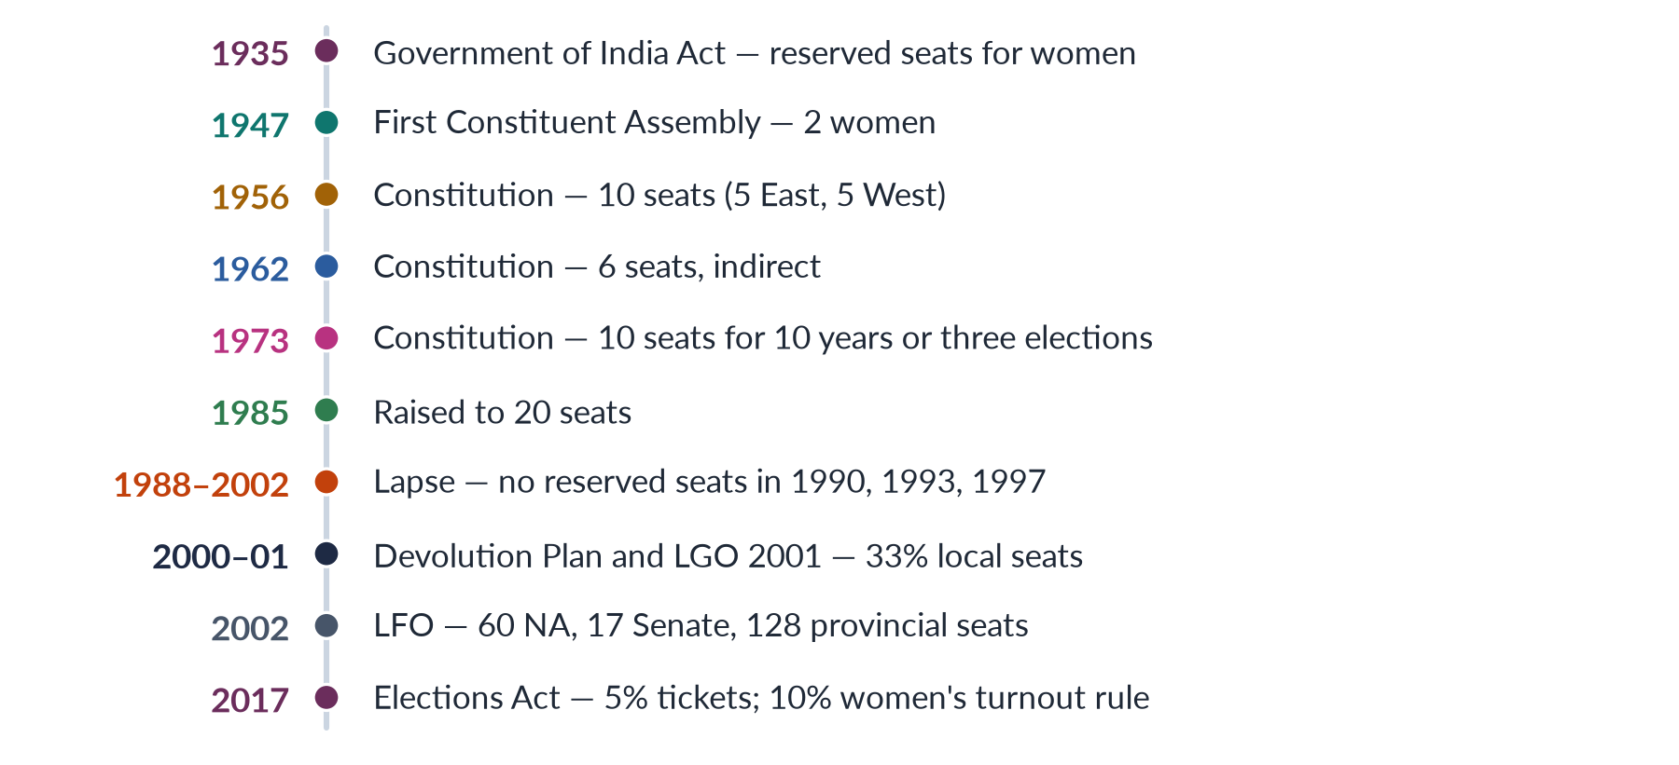
Figure 18 · The evolution of women's quotas in Pakistan.

8. 1988–2002: the lapse and its lesson
The provision expired after the 1988 election. In the elections of 1990, 1993 and 1997 there were no reserved seats, and only two to six women won general seats — a National Assembly over 97% male. This happened even under Benazir Bhutto, who promised to restore the seats but lacked the majority or will. The lapse is the strongest historical argument for quotas: without them, women almost vanished.

9. 2000–2002: devolution and the LFO

i) Local government
Pervez Musharraf's Devolution of Power Plan (2000) and the Local Government Ordinance 2001 reserved 33% of council seats for women; about 36,000 women were elected — the largest entry of women into public office in Pakistan's history, though some seats in conservative districts went unfilled.

ii) The Legal Framework Order 2002
The LFO 2002, validated by the 17th Amendment (2003), enlarged the National Assembly to 342 and reserved 60 seats (about 17%), plus 17 in the Senate and 128 in the provinces, filled by proportional representation from party lists.

iii) Related policies
The NCSW (2000) and the National Policy for Development and Empowerment of Women (2002) formed part of the same package. Women's share of the Assembly jumped from under 3% to over 20%. Critics noted that a military ruler had introduced the change, but every elected government since has kept it.

10. 2008–2018: consolidation and reform
- 2008: the cross-party Women's Parliamentary Caucus turned numbers into laws (2010–2016).
- 2010: the 18th Amendment retained reserved seats and Article 34.
- 2013 onwards: provincial local government laws kept women's seats but mostly below 33%.
- 2017: the Elections Act introduced a 5% candidate quota (Section 206) and the 10% women's turnout rule (Section 9).
- 2018: the 25th Amendment merged the tribal areas; the National Assembly fell to 336 seats, with 60 still reserved for women.

iv) An example of the quota at work
The cross-party Women's Parliamentary Caucus, formed in 2008 under the first woman Speaker, Dr Fahmida Mirza, turned the 2002 numbers into laws: on workplace harassment (2010), acid attacks and anti-women practices (2011), the NCSW Act (2012) and honour killing (2016). Without the 2002 quota, there would have been no caucus large enough to pass them — the clearest proof that the quota's evolution changed real outcomes for women, not just the numbers in the house.

11. Assessment

i) Gains
A permanent, larger quota since 2002; a candidate quota since 2017; protection of women's votes; women at about one-fifth of the Assembly; and landmark laws passed by women.

ii) Gaps
Seats are still filled indirectly by party leaders; the 5% rule is weak; only 11 women won general seats in 2024; local quotas were cut; and parties treat reserved seats as a ceiling. The 2024–25 dispute over the allocation of reserved seats to PTI-backed independents showed that the system still turns on party arithmetic.

12. The next stage and conclusion

i) The next stage
Direct election of women's seats; a candidate quota of at least 33% in winnable seats; restored 33% local quotas; and transparent party lists — following Nepal, where constitutional quotas produced about 35% women in 2026.

ii) Conclusion
Pakistan's women's quota has evolved from colonial reserved seats, through small indirect quotas in 1956, 1962 and 1973, an increase in 1985 and a damaging lapse, to the substantial system of 2002 and the reforms of 2017. Each stage was shaped by its political context. The quota has moved from symbolic to substantial; its next evolution must make it empowering.

Why this answer scores
- Covers every phase in order, with the law or policy behind each.
- Explains the context of each change (Ayub, Zia, Musharraf), not just dates.
- Uses the lapse as evidence and ends with an assessment and next steps.
- A timeline figure shows the whole evolution at a glance.

